Is My Love of the Sea in My Genes?
or
My Seafaring COUCH Family of Port Isaac

In the late 1950s, when I was between nine and fourteen years old, I lived in a little fishing village called Donnybrook, on the mainland of Australia just near Bribie Island. My adoptive father was a professional fisherman and crabber and we also had a boat hire business with a launch, ten boats with inboard motors and about 30 dinghies. Before and after school and on weekends and school holidays, I used to help Dad with the boats. My favourite job was going out with him at 5am to check the crab pots – I would steer the boat along side the crab pot and he would empty the pot and tie the crabs. It was beautiful out on the water at daybreak. Freshly caught and cooked mud crab is still my favourite meal.

I’ve always loved being beside the water and really missed the ocean during the couple of times of my life when I lived a long way from it. I believed that I developed that love during my time at Donnybrook. Now, I’m not so sure. Perhaps it was always in my genes?

My research into my birth family, since 2001, when I discovered that I was adopted, has made me think that this love was passed down to me through my genes. My Great Great Grandmother, Elizabeth COUCH who migrated to Australia with her husband, Isaac Hawker, in 1862 was descended from a long line of seafarers from Port Isaac in Cornwall in the South West of England.

Port Isaac is the beautiful little coastal town that we all know and love as Port Wenn, the setting for one of my favourite television shows, Doc Martin. However, back in Elizabeth’s day, it was not such a pleasant place to live. The fishermen’s rough cottages were along the shoreline and the only way to enter the village was by boat or on foot or horseback. The harbour was very dangerous and the breakwater wasn’t built until the 1930s. There was no sewerage system and all waste just ran into the sea. It wasn’t until after World War II that the government built new houses at the top of the hill and relocated the residents into much more liveable housing. Since then, wealthy outsiders have bought the cottages and renovated them, mainly as holiday homes.

In 2016 we spent a few days renting a farm stay cottage, Wheel Lodge, just close to Port Isaac and undertook some research, meeting cousins and generally investigating. I went into the Port Isaac Book Shop and asked if they had any books on the history of the place and was sold a copy of “The Fishermen of Port Isaac” by Geoff PROVIS, a local man. I was thrilled to find mention of some of my relatives and even photos. Just recently I have obtained his second book, “The Seafarers of Port Isaac” and once again found more details of my family. I want to thank Geoff for his research and for writing these books as they have provided me with so much information. I will quote from his books and share photos from the books as I write this story. One of the cousins we met, on this trip, was Beryl Chandler, nee Powell, a fifth cousin on this Couch line and Beryl, who has been researching for much longer than I have was happy to share her findings with me so I want to sincerely thank Beryl too.

The main locations that I will mention in my tale are Port Isaac, St Endellion (about 3km from Port Isaac), St Kew (about 6km from Port Isaac), Trelights (very close to St Endellion) and two neighbouring ports, Port Quin and Port Gaverne. This map will show you their locations: (If the link doesn’t work, copy the link and paste into your browser.)
https://getoutside.ordnancesurvey.co.uk/local/port-isaac-cornwall

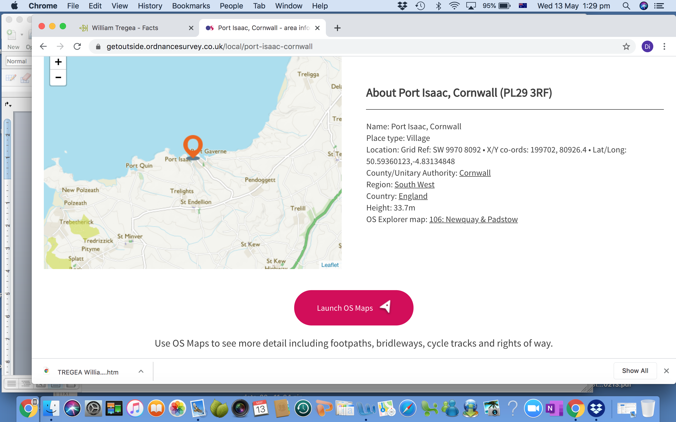

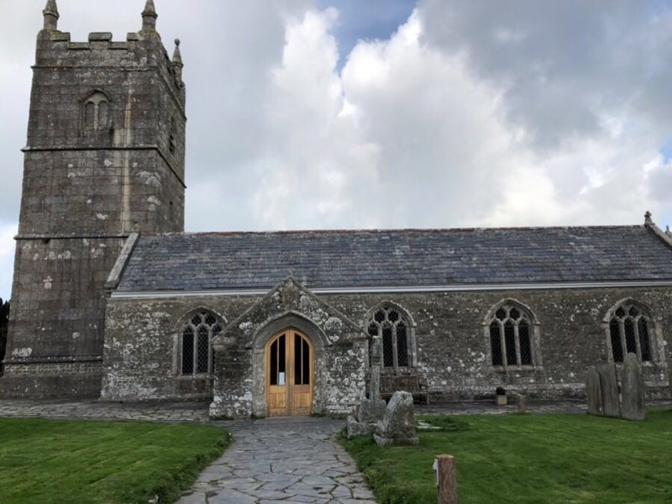
My story is going to begin with the birth of my GGGG grandfather, Charles COUCH on 28 October 1763 at St Kew to John COUCH and Letitia FRAD. (I need to warn you that, although I will do my best to make this story easy to follow, many of the COUCH family had many children and they all seemed to name their children after their siblings so the same names are found in different generations. This can be very confusing.) Almost all of the men were Seafarers and almost all the women married Seafarers.
Figure 1 St Kew Church

I wrote all of the above in April 2020 but then I started researching further to work out how best to show the links between the people I have found. It is now December and I have found that the more I research, the more I find about the family. I think all of the original families in Port Isaac were interconnected in some way so I have found so many linkages and have had much fun in the research. There’s too much though to put in one short story. I have added the results of my research to my public Ancestry family tree and I’ve decided that this will be a story of the occupations that family members followed. The references for my findings can be found on my Ancestry Tree (The Alley Family tree) and I will not be referencing in the story.

Charles COUCH (1763-1852) (My GGGG Grandfather)

Honour PHILLIPS, my GGGG grandmother, was born on 9th August 1774 at St Endellion to Samuel PHILLIPS and Mary WEBBER. She married Charles COUCH, my GGGG grandfather on 26 March 1796. They had thirteen children, seven girls and six boys.

In the History of Port Isaac and Port Quin, Dr. Frederick Trevan 1833 – 1834 states that “ Charles Couch: Fisherman, originally of St. Kew. First came as a Hog dealer. Likewise Master Seaman to "Good Intent". Pilchard seaman for several years. Married Honor Phillips by whom he has ten children, mostly dispersed. Total five in house.”

I think the discrepancy in the number of children is probably because of the death of three or maybe four as infants. When his son Francis (my GGG grandfather) was baptised the certificate shows that Charles was then a Master Seaman.

Charles died in April 1852, aged 88 and was buried on 12 April 1852 at St Endellion. Honour died in August 1868 having lived to be 94 and was also buried at St Endellion. There are many tales of smuggling in these coastal villages of Cornwall but the only reference I can find to any wrongdoing by the COUCH family so far is a mention in the Criminal Registers of Cornwall that Honour COUCH was sentenced to 18 days imprisonment for receiving stolen goods. My guess is that this would have been goods that washed up on shore after a shipwreck. Their life was very tough. The seas were rough and Port Isaac was not a safe port. Honour, like all the wives of Mariners through the ages, would have not known when, or if, their husbands would return and many were left with young children to care for on their own. Fortunately, Charles and Honour both lived very long lives.

Charles COUCH (1797-1883)(My 4th Great Uncle & 1st child of Charles & Honour)

The first child of Charles and Honour, also Charles was born on 7 July 1797 and was baptised at St Endellion on 5 November 1797. On 29 December 1825 he married his cousin Mary PHILLIPS at St Endellion. Both Charles and Mary were literate and could sign their names on the certificate. Witnesses to their marriage were Charles PHILLIPS and Richard APPS. Was Charles PHILLIPS her brother? Possibly? The family is also linked to the APPS family so perhaps Richard was a cousin?

Between 1830 and 1835, Charles was the Captain of The Afro working in the coastal trade out of Padstow employed by Rosevear and Sloggett at Boscastle. By this time, they have three children: Mary Phillips COUCH, baptised at St Endellion on 8 July 1827, Theophilus Phillips COUCH, baptised on 25 October 1829 and Elizabeth Phillips COUCH, born 31 March 1832.

For the next nine years, Charles was Captain of The Pennally working the coastal trade out of Padstow and, of course, he and Mary had more babies: Honor Phillips COUCH in 1836, Hannah Phillips COUCH in November 1839, Letitia COUCH in 1841 and Eliza also in 1844. (If my spelling confuses you, I apologise. Honor is sometimes spelt with a U and sometimes without and Phillips is spelt with one or two Ls and one or two Ps. I have really appreciated the use of the mother’s maiden name as a second name as it really helps to identify which person you’re referring to.)

From 1844 to 1850 Charles was Master of The Letitia also out of Padstow in the costing trade. On 10 February 1851, he was issued with his UK and Ireland, Masters and Mate's Certificates – certificate number 36.786 in Plymouth. He declared that he had begun as a seaman on The Cornwall on 20 March 1820.

In the 1861 census we find Charles, a retired Master Mariner and Mary living in Port Isaac with their daughter Hannah and their 6 year old grandson, another Charles. In 1871 they share their home with another daughter, Letitia, and another grandson, William. Letitia was single.

Mary died on 21 November 1871 and was buried at St Endellion. The 1881 census shows Charles still living with Letitia who is a Dressmaker. He died on 11 October 1883 and was buried with Mary at St Endellion. His probate was granted on 10 December 1883 and his executors were his son Theophilus COUCH, a Stockbroker of Pentewan, St Austell and Robert BROAD (husband of his daughter Hannah) who was a Farmer.

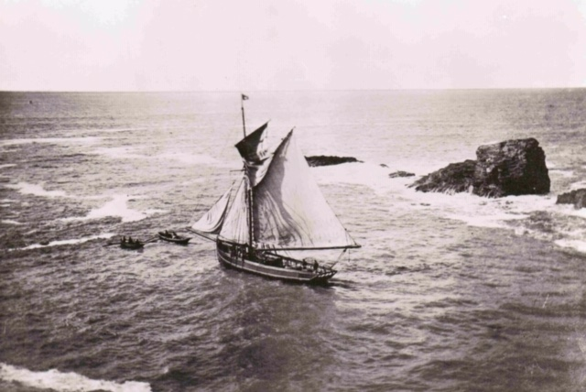
Figure 3 A boat loaded with Delabole Slate in Port Geverne Harbour. We know that this is not a Port Isaac boat as ships this size could not moor at PI.
Did the sea continue to play a role in the lives of the children of Charles and Mary? Mary married William Henry COUCH who was a Master Mariner in 1846. (I’m unable to determine if they are related in some way at this stage.) She died in 1901 and he in 1895.

Theophilus married Hannah Maria SARAH in 1852. They had three sons: Charles Phillips COUCH b1855, Humphry Charles Phillips COUCH b1855 and Theophilus William COUCH b1856. Hannah died in 1884 and he married again to Martha Kellow FISHLEY in 1885. In 1871 the family were living in Pentewan and Theophilus was a Shipbroker. In 1881 he and his son Theophilus, usually called William, were both Shipbrokers. Theophilus died on 13 August 1917 and was buried at St Endellion. He and Martha had been living in Port Isaac.

Elizabeth Phillips COUCH married Thomas RICHARDS on 1 December 1858 at St Kew and Thomas, too, was a Mariner.

Honor Phillips COUCH married James HAMBLY, another Mariner, on 11 April 1858 at St Endellion.

Hannah chose a Farmer, Robert BROAD when she married in 1864. Letitia did not marry and supported herself as a Dressmaker and Eliza died in 1849 when she was just five years old.

Nicholas COUCH (1798-1873)(My 4th Great Uncle and 2nd child of Charles & Honour)

Nicholas was born in 1798 in St Endellion and married Thomasine MEDLIN on 29 September 1821. She was born in Tintagel, Cornwall.

They had five children: William Henry in 1822, Mary in 1825 who died at birth, Charles on 3 October 1826, Nicholas in 1829 and Mary Jane in 1833.

In the History of Port Isaac and Port Quin, Dr Trevan states “Nicholas was Master of the "Jane" in employ of Rosevear & Sloggett of Boscastle. He was married to Tasmen MEDLEN of St Teath and has 4 children.” Records show that he sailed The Jane along the British coast visiting ports such as Padstow, St Ives and Boscastle.

In the 1851 Census, Nicholas is living in Port Isaac with Tamzin and Mary Jane and he is a Fisherman. Many of the Mariners became Fishermen as they aged and felt that life on a sailing ship became too difficult. However, in 1861 he is once more listed as a Mariner and he and Tamson are living at 23 Billy’s Rowe, Port Isaac. The 1871 census shows them living at 158 Fore St and he is a Fisherman and Sailor.

He died aged 75 on 6 June 1873 and was buried at St Endellion. Thomazin died on 16 September 1878 and was buried with Nicholas.

I can find no further information on their son, William but Charles gained his Mate’s certificate on 14 May 1851 and the 1871 census shows him living at 10 Town St, Tower Hamlets, Mile End Old Town, London with his wife Emma. Nicholas married Mary Jane Kingston at Megavissey, Cornwall on 22 August 1856. Both Nicholas and Mary Jane’s father were Sailors. Nicholas died in April 1863 when he was just 34 but I cannot find the cause of death. Was he drowned at sea like so many others? Mary Jane married John PRIDEAUX who was a Pilot. She died in 1893, aged 60.

Samuel COUCH (1799-1833)(My 4th Great Uncle and third child of Charles and Honour)

Samuel was baptised at St Endellion on 27 January 1799 and he married Hannah Treffry BISHOP there on 27 December 1821. They had two children that I have been able to identify: Thomas Treffry COUCH (13 November 1823) and Jane Bishop COUCH (1830). At the time of Thomas’ baptism, Samuel was a Fisherman. He died in 1833 and was buried at St Endellion on 17 March that year. Again, I am unable to discover if he died at sea.

In the History of Port Isaac and Port Quin, Dr Trevan writes of Samuel: “(Late). Seaman. Died about two years since. Left a widow, daughter to Jane Bishop, with many children. Six in house. Was an excellent seaman”. However, I have been unable to find further children. Thomas became a Master Mariner and Jane married James Mason FISHLEY who was also a Master Mariner.

Letitia COUCH (1800-1889) (My 4th Great Aunt and 4th child of Charles and Honour).
Letitia was born on 11th September 1800 at St Endellion and was baptised there on 31 January 1802. She broke away from the families’ links to the sea as she married William TREGEA, a Miner, on 6 March 1830 at St Neot, Cornwall. (This is 39km from Port Isaac. Why was she there? Was she working as a servant perhaps?)

They then migrated to the United States where their children were born: Mariana (1831-1890), Susan (1833-1910), Leonard (1834- 1916), William (1836-1927), Hannah Maria (1838 – 1930), Mary J (1841-1926) and John F (1843-1862). None of their children had any connection to the sea. Mariana married Thomas MALONEY who was a Soldier in the Civil War. Susan was a Tailoress and she married James Alexander HENDERSON. Leonard married Emma PETERS and worked as a Printer while William married an Elizabeth and worked as a Harness Maker. Hannah was a Milliner and married Daniel Henry CLEAVES who was a Carpenter. Mary J was also a Tailoress and her husband, Silas JOSLIN was another Harness Maker. John F was killed on 28 August 1862 in Gainesville Virginia in service to the Union Army in the Civil War.

Letitia died 4 June 1889 in Antioch California when she was 88 years old. So absolutely no Mariners there and a totally different life on a new continent! I have records of a William TREGEA moving to Chile in a specialist mining role and then back to the United States and I think it is Letitia’s husband but I can’t find any records to substantiate that.

John COUCH (1803-1864) (My 4th Great Uncle and 5th child of Charles and Honour).

John COUCH was born in 1803 and married Elizabeth BISHOP at St Kew on 25 October 1828. They had five children: Matilda (1833 -1854), Thomas (1838), Grace Elizabeth (1838), George (1841) and Henry (1845-1854). There are no Mariners in this family either and I have little information about them all. Both John and his son Thomas were Millers; Matilda and Henry both died young and Thomas married Mary Hannah Wollcock at St Kew on 15 July 1860.

Honour COUCH (b1804 d Unknown)) (My 4th Great Aunt and 6th child of Charles and Honour).

Unfortunately I have been unable to find any information about Honour except that she was baptised at St Endellion on Christmas Day 1804.

Mary COUCH (1806-1890)) (My 4th Great Aunt and 7th child of Charles and Honour).

Mary was born in 1806 and she married John PROUT at St Endellion on 6 September 1828. John worked all his life as an Agricultural Labour. They lived their early life in Port Quin but the 1871 census shows them living in Christmas St, Horley in Surrey.

All told they had 11 children, six of whom were girls. Only two of the boys chose a life on the sea. Samuel Couch PROUT born 1844 was a Master Mariner and he died in Port Isaac on 26 August 1882 when he was only 38. He married Phillippa Mably KELLOW in 1871 and they had two sons both of whom died as children. He left £195 to Phillippa in his will.

Samuel had been the owner of the New Cornwall, which was captained by his younger brother Richard PROUT when it sank on 21 December 1876. Richard was lost at sea. He was just 27. He had been married to Martha Kellow FISHLEY for fourteen months.

Most of the daughters married Agricultural Labourers although Elizabeth (b1842) married Thomas GUILFOY who was a Prison Warden and Mary Jane (b1838) married Thomas HICKS who was a Gardener. John (b1832 d1890) was married to Ann KELLOW and he farmed his own seven acres of land at Port Isaac.

William COUCH (1807-?)) (My 4th Great Uncle and 8th child of Charles and Honour).

William was born on 29 September 1807 and married Mary HOSKIN on 27 November 1834 at St Endellion. He worked his way up from Boy to Mate to Master Mariner and was involved in the coasting foreign trade. When he gained his Master’s Certificate in 1851 he had been 25 years in the British Merchant Services. I have found records of him being Master of several ships out of Cork, Ireland including The Hafre, The Firecuan and The Gasfrer.

William and Mary had two children, William (b1841) and Elizabeth Hoskins COUCH (b1842). The 1871 census shows that William and Mary are living in Port Isaac with Elizabeth who was a Dressmaker and was married to William Henry FURSE (b1838 d1885). Both William, himself, and his son-in-law were Fishermen. Elizabeth & her husband migrated to New Zealand where he was also a Fisherman. They had one child, Mary Ida in 1869 but she died 22 December 1889 in Wellington New Zealand when she was just 20 years old.

William and Mary’s son, William, was also a Mariner and in 1861 he was Master of The Catherine.

I can’t find definitive records to show the death of William or his son William.

Elizabeth COUCH (1808)) (My 4th Great Aunt and 9th child of Charles and Honour).

I can find almost no information about Elizabeth apart from her Christening at St Endellion on Christmas Day 1808.

Betsy COUCH (1810)) (My 4th Great Aunt and 10th child of Charles and Honour).

All I can discover, with any certainty, about Betsy is that she was christened at St Endellion on 28 December 1810.

Susan COUCH (1812)) (My 4th Great Aunt and 11th child of Charles and Honour).

Susan was also christened at St Endellion, on 27 September 1812.

What happened to these three girls? Did they all die young? I’d really like to find out.

Hannah COUCH (1815) (My 4th Great Aunt and 12th child of Charles and Honour).

Hannah was baptised Anna on 10 June 1815. She married William Rodman THOMAS in 9 November 1840. William was a Mariner and they went on to have nine children, the first of which were twins: Hannah Maria and George who were born in 1840. George died when he was just 12 and Hannah died when she was seven.

Their third child, Letitia Couch THOMAS was born in 1842 and she lived only until she was 17. William Rodman THOMAS was born in 1844 and died in 1860 in Somerset. Did he drown at sea? I’ve been unable to find out.

Anna (Hannah) Maria THOMAS was born in 1848 and in 1871 was working as a Servant (she was a Nurse) to the SEGOE family – Mr SEGOE was a Master Mariner and they lived at West Park House in Egloshayle. I can find no further information for Anna. Marina THOMAS was born in 1848 and Mary in 1851. Again, I can find no further information about these two children and I’m thinking that they too probably died young.

What a terribly sad time these parents had, especially Hannah as William would have been away at sea and she would have had to manage on her own.

Charles Couch THOMAS was born in October 1852 and, it seems he was quite a character according to Geoff PROVIS in his books. Gossie, as he was known, married Eliza Selina COUCH, one of the daughters of his mother’s brother, Francis and so his cousin, on 17 June 1874 at St Endellion. She was working at the St Kew Vicarage where they met. He was a seafaring man and apparently, his boat called at Appledore so he walked or went by pony (shades of Captain Poldark) to visit Eliza. He also walked the 22 miles from Padstow to visit her. How romantic!
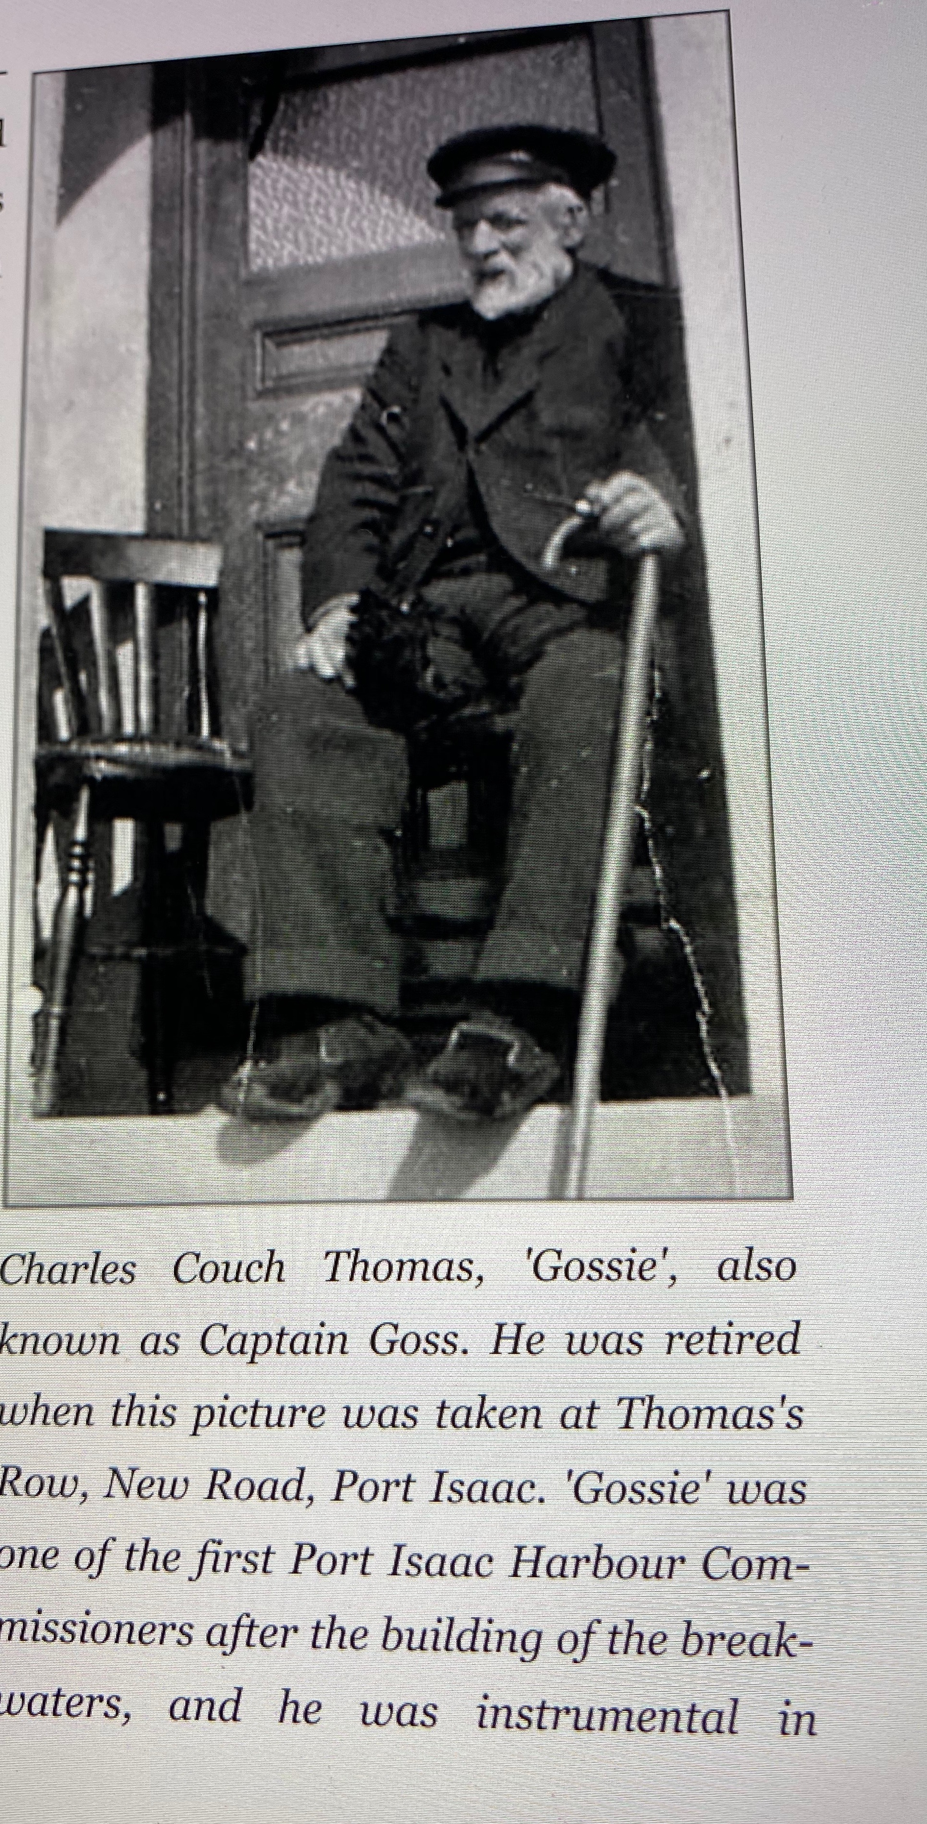
Charles and Eliza had eight children: William Rodman THOMAS (1876 -1903), Samuel Couch THOMAS (1876 – 1949). Charles Couch THOMAS (Dry) (1879 – 1936), Marina Couch THOMAS (1880 -1884), Lizzie Couch THOMAS (1883 – 1893), Francis Couch THOMAS (Frank or Joey) (1885 - 1974), Eliza Selina Couch THOMAS) (1889 -1959) and John Hale Couch THOMAS (Jack) (1891 -1972)

On 15 April 1891, Gossie was Captain of The Scout and his sons, William and Samuel were Ordinary Seaman on the ship. The 1901 census shows both Gossie and William living at 31 Church Hill, Port Isaac and they are both Fishermen. At the time of the 1911 census, Gossie was 58, a Fisherman and a widower and he was living with his son Samuel (35), also a widower and now a Master Mariner. His daughter-in-law, Eliza THOMAS was their housekeeper and a grandson, another William Rodman THOMAS, son of Samuel and Elizabeth MORMAN (1877 – 1909) also lived with them.

Samuel Couch THOMAS enrolled in the Royal Naval Reserve on 1 April 1904. His papers record that he had brown eyes and a ruddy complexion. He was 5ft 4 and he served on several ships including the yachts: Mesa and Anita.

Charles Couch THOMAS (Dry) was also a Mariner and he owned the trawler Our Girlie. He kept it at Padstow as it was too large for the harbour at Port Isaac. On 27 November 1928, it was wrecked on rocks at Port Quin and unfortunately, he hadn’t finalised the insurance. The crew were all saved but Dry was forced into bankruptcy.

The two daughters, Marian and Lizzie, both died very young.

Francis Couch THOMAS (Frank or Joey) also signed up for the Royal Naval Reserve on 18 March 1905 in Padstow. His number was 3174 and he had a fair complexion and grey eyes. He married Susan ROWE (1883 – 1976) in 1909. The 1911 census shows he and Susan and their son Frank, Living in Port Isaac where he was a Mariner serving in the costal trade on sailing ships. Joey lived to the ripe old age of 89.

Eliza Selina Couch THOMAS was born 26 May 1889 and she married Thomas TABB, a Mariner and Fisherman. She died on 3 February 1959.

The last child of Gossie and Selina was John Hale Couch THOMAS (Jack) who was born on 7 February 1891. On 29 September 1939, The Tabbs live next door to Jack and his wife Jessie ROWE (b1890 – d1976) who live at 6 New Rd, Port Isaac. At that time, Jack was working as MATE on a yacht and fishing at other times. I haven’t found any children for Jack and Jessie. He died on 27 November 1972 and was buried at St Endellion.

Geoff Provis states in “The Fishermen of Port Isaac”: “Frank (Joey) THOMAS, Jack Hale THOMAS, Harry LEVERTONE and Ralph COUCH were out herring fishing on The Cissie in the late nineteen twenties or early thirties. They had such a heavy catch that there was only one inch of freeboard left. Harry and Ralph were bailing water and herrings as fast as they could go. Jack Hale was on the engine and Joey on the tiller. Every sea was coming aboard and they did not think they would make it back to the beach. There was also ground sea and luckily they managed to sue in on Port Isaac beach with 28,000 herring. They all said later that the nets should have been abandoned or cut away.” Seafaring was definitely a dangerous occupation.

Gossie, who is my 1st cousin 4x removed, died on 10 May 1929 and Eliza, his wife, who is also my 1st cousin 4x removed died on 21 April 1910. This branch of the family certainly carried on the seafaring traditions. Geoff reports that Gossie used to assist others with legal matters.

The last child of Hannah and William Rodman Thomas was Martha Alma THOMAS who was born in 1855 and married William John LOBB on 20 March 1877 at St Endellion. The marriage certificate shows that William is a Mariner and both of their fathers are Master Mariners. The LOBB name features heavily in both of Geoff Provis’ books as they too were Mariners and Fishermen. Martha and William had nine children.

The eldest was Alma Letitia LOBB (1878 – d1962) who married John Lovell BROWN (b1873 d1932), a Mariner involved in coastal freighting. Beatrice was born in 1880 and Lizzie in 1882 and I have no further information on these girls. Perhaps they died young? William John LOBB was born on 3 November 1883 and he married Annie COUCH, daughter of Charles COUCH and Elizabeth HILL and a cousin. He was an Inshore Fisherman in 1939. He died on 29 May 1955. George was born in 1886 and he was still alive in the 1891 census but after that I can find no further information. Richard was born in 1887 and he migrated to Canada in 1907 where he became a Printer. He married Mattie, a Canadian and he died in Weyburn, Saskatchewan, Canada on 5 March 1968. For Marina (b1890), Rodmond (b1892) and Martha (b1896) information is scarce.

Francis COUCH (1816)) (My 3 Great Grandfather and 13th child of Charles and Honour).

Francis, the last child of Charles and Honour, was born on 16 June 1816 in Port Isaac and was baptised at St Endellion on 21 July that year. I am, of course, directly descended from Francis and his wife, Rebecca HILL.

When he was 16 he served as The Boy on The Louise and Rachel out of Padstow and they worked the coasting trade. He worked on other ships including The Afro as a Seaman and then on The Pennale as Mate between 1835 and 1838.

On 19th December 1837 he married Rebecka HILL (b1820 d1893) at St Endellion. They were both living in Port Isaac and Rebecka’s father, Samuel HILL, was a Blacksmith.

Over the next few years he worked as a Seaman on The Magnet Packet and The Sprightly engaged in the foreign coasting trade and as Mate on The Aid out of Padstow involved in coasting. In 1840 he was Mate on The Letitia and then between 1842 and 1845 he was Master of The Aid working the coastal trade and then between 1845 and 1846 he was Master of The Mary. Following that, he was Master of The Caroline and The Jane out of Padstow, always in the coasting trade.

It’s always a great feeling when you find a document handwritten by your ancestor and I was lucky enough to find a declaration written and signed by Francis on 1 June 1861 in Swansea, Wales. In it he states that the information contained in his application for the renewal of his Master’s Certificate is true and correct.
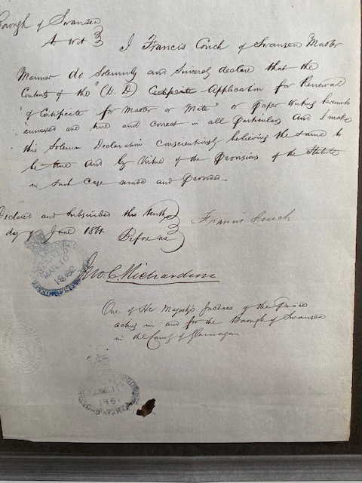

During the first eight months of 1863, Francis served as Master on The Eliza out of Plymouth and he had previously served on this ship. On the night of the 1871 census, he was Mate on The Ada and his son Samuel was the Boy – he was just 14. The Captain was Thomas Hawky, a Port Quin man. During the second half of 1872, Francis served as Mate on The Jane Sophia. In 1881, he was on The Mary Waters and during 1882 he was Cook and Steward on The Scout.

Rebecka and Francis had ten children over 22 years. The eldest was George COUCH who was born in October 1838. George married Ada BROWN in 1875 (b1854 d1933) and they had six children. George followed the family into the seafaring life and died in Port Isaac in October 1895 where he was buried at St Endellion.

Their second child was Elizabeth COUCH, my Great Great Grandmother who was born in March 1841 and was baptised on 7 September 1845 when she was five years and three months old. She married Isaac HAWKER on 3 May 1862. 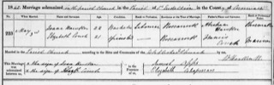
Figure 4 Marriage certificate of Elizabeth and Isaac
They had both been working at Roscarrock Farm at Port Isaac where Isaac was a Carter. Isaac’s father was a Cordwinder or Shoemaker. Soon after their marriage they boarded The Accrington for Melbourne, Australia arriving 24 August 1862. In the ship’s manuscript, Isaac gives his occupation as Farm Labourer and Elizabeth gives hers as Dairywoman. During the journey on 30 July their first son was born. I can’t imagine how it felt to make that journey so young and pregnant – how brave they were! Unfortunately, the baby, Abraham died the same year at Sea Lake, Victoria. On arrival they had a contract for three years to work for a Mrs Gander at Upper Yarra, Victoria at a salary of £40 per year.

Elizabeth & Isaac went on to have a total of eleven children but it wasn’t easy. Frank Couch HAWKER was born in 1864 but died in 1865. Hannah was born in 1865 and died in 1909 while Henrietta was born in 1866 and died in 1870. How tough this must have been especially being so far from home and family support?

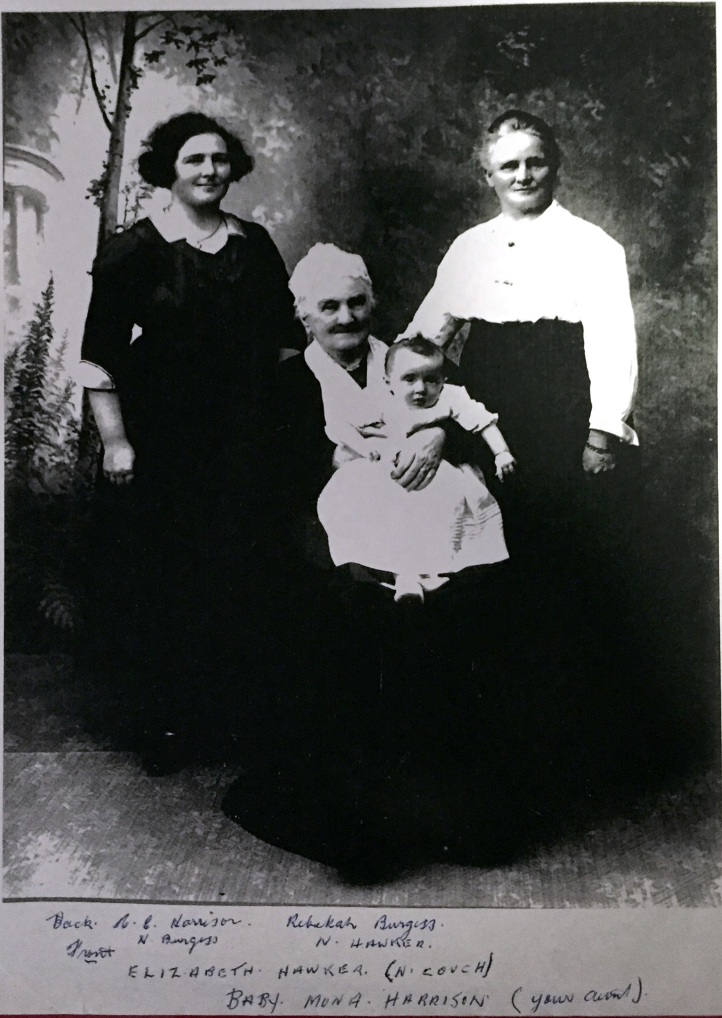
Mary Elizabeth (b1868 d1952) married George BORROW who may have been a Stoker but I’m not sure about that. Georgina (b1870 d1914) married James Christopher JENNISON (b1869 d 1955) in 1897. James was a Methodist Minister.
Jane Ann (b1871 d1934) married a Dairyman, Thomas CROPLEY.

My great grandmother, Rebecca was born on 25 November 1871 at Wyndham, Victoria and she married Joseph Henry BURGESS (b1865 d1945), a Dairy Farmer in 1893 at Werribee in Victoria. Joseph and Rebecca were innovative farmers and operated the first dairy in Victoria to install refrigeration. The dairy was in St Kilda, now a very well known beachside suburb of Melbourne. I wonder if Elizabeth used to visit and milk a cow or two sometimes, for old times’ sake.

Eliza (Lulla) was born at Altona, Victoria on 11 March 1875. At this time, Isaac was, I think working at of the Altona Bay Estate where he later became Manager. She married Edward SANDERSON who was a Railway Worker, in 1912 and died in 1952.

Their next child, Eda Bertha, was born in Wyndham in 1878 and she married a Carpenter, John WHITE in 1912. They had one son and two daughters and Eda died in 1955.

Annie Francis was the last child of Elizabeth and Isaac. She was born in 1880 and lived a short life, dying in 1918.

Once Elizabeth and Isaac left England and made a new life in Australia, the connection to the seagoing life appears to be broken with none of their descendants choosing this difficult life. They did however, continue with the other traditional occupation in Port Isaac: working on the land.

The next child of Francis and Rebecka was Rebecca COUCH (b1843 d1926) who married Edwin KELLOW (b1848 d 1942), a mason. They had seven children.

Mary Hill COUCH (4th child of Francis and Rebecka) married Joseph Pascoe BILLING (b1841 d1909), from another seafaring family on 4 July 1865. In September 1874, Joseph was Mate on The Bessie Waters, out of Padstow. He must have received a bad knock because he then had 34 days in the Dreadnought Seaman’s Hospital with hematocele, a problem with his testicles. All must have been well though because they had nine children. The Eastern Maid, owned by John KELLOW of Pentewan featured in their life. In June 1882, Joseph and his eldest son Joseph (15) were serving on this schooner, a fishing boat, under Captain Richard HOSKIN. Unfortunately it was lost at sea on 22 October 1885 when Joseph (now 18) and his brother, William (15) were both on board but their father was not on the boat at that time.

The fifth child of Mary Hill COUCH & Joseph Francis BILLING was Hannah COUCH (b1849) who married Captain Thomas BROWN (b1834 d1892), a Master Mariner. They had two daughters, Marina Thomas BROWN and Nancy BROWN.

Their next child was Eliza Selina COUCH (b1851 d1910) who married Charles Couch THOMAS (Gossie). Gossie was Eliza’s cousin and I have already told their story.

Francis C COUCH was born to Francis and Rebecka in 1853. Francis married Hannah Marina FISHLEY (b1853 d1910) on 6 April 1874 at Plymouth and this particular family had a really sad time of it. Their first child, Charles Olonza COUCH was born in Port Isaac in 1876 and he was baptised at St Endellion on 23 August 1883. He married Lilian MITCHELL from Port Gaverne in 1904. Unfortunately, he was lost on or about 18 November 1905 when he was washed overboard from The Tregea, a schooner of which he was Master.

Their next child, Laura Ellen was born at Plymouth on 6 April 1878 and the 1901 census lists her as living with her parents in Port Isaac. She is a married woman, Laura Ellen AVERY and her husband is a Mariner, John AVERY (b1875 d1956). They had three children: Ralph, Edward Charles and Elizabeth E. Laura died on 28th December 1953 in Croyde, Devon and was buried with her husband John at Croyde. Their son Ralph was listed as an incapacitated cripple in the 1939 Register and he was living at home at The Anchorage in Croyde. Edward was a Carpenter. The family travelled a bit, even living at Waterford in Ireland for some time.

After Laura came Francis who was born in 1879 and died on 13 June 1880 and was buried at St Endellion. He was only 13 months old.

Then came Annie who was born on 29 January 1882, married Fletcher SWEET (b1878 d1958) and had one child, Allen in 1918. The 1939 register listed Fletcher as a Yacht’s Boson.

Frank was born on 11 August 1894 and was baptised at the Port Isaac Chapel on 15 September 1894. The 1901 census lists him as the Cook on The Deveron. In 1911 he was living at 1 Birmingham St, Southampton Cheshire and was a Deckhand in the Merchantile Service. April 6, 2012 was a momentous day in his life: He signed on as an Able Bodied Seaman on The Titanic for its maiden voyage from Southampton to New York. He was to be paid £5 per month. He gave no local address but indicated that he had previously served on The Modwera. I reckon that would have been really good money and all the crew would have been so excited to be part of the maiden voyage of this supposedly unsinkable ship, about which there had been so much hullaballoo. However, as we know, disaster struck when the ship hit an iceberg some four days into the trip, late on the night of 14 April. There were insufficient lifeboats and The Titanic took about 2hrs and 40minutes to sink. Apparently the evacuation was chaotic and disorderly and there were only enough lifeboats for about a third of the people aboard, even if they had been filled to capacity. Fifteen hundred people drowned. Among them was Frank COUCH who was manning one of the lifeboats. His body was recovered by the Mackay Bennett and he was body number 253. He was buried at Halifax in Nova Scotia, Canada. He is also mentioned on his family headstone in Port Isaac. This Port Isaac Heritage page has more details. file://localhost/Users/davidedelman/Documents/Family Research Alley/COUCH Frank Titanic Pt Isaac website.htm Last year (2019) we were lucky enough to be in Southampton where there is a Titanic museum. It was Good Friday and I was disappointed as I thought it would be closed. However, I walked there and to my delight it was open and there on the wall was Frank’s name. I thoroughly enjoyed my couple of hours there before I boarded my cruise ship, The Marina, one of the Oceania liners.

The next child born to Francis C COUCH and Hannah on 5 June 1886 was Martha COUCH. In 1910, Martha married Harold James BATE (b1881 d1949). In 1911, Martha, Harold and their 10 month old son, Harold Francis were living at 3 Elton St, Plymouth where Harold (senior) was a Mariner with HMS Dredger. Martha lived to be 69 and left £3,155 to her son Harold Francis who was a Civil Servant.

Ralph COUCH was born 20 June 1888 and he lived a long life dying on 17 April 1968.
The 1911 census shows that he was a single man in the Royal Naval Reserve and he boarded at Tormoham in Devon. Ralph married Susie STONE (b1893 d1966) in January 1914. They had three children: Sylvia in 1914, Anita in 1919 and Jack in 1922. Sylvia married Charlie JULIAN and I have no further information about them.

However, Geoff Provis has put me in touch with Anita’s grandson (Neil SWINYARD-
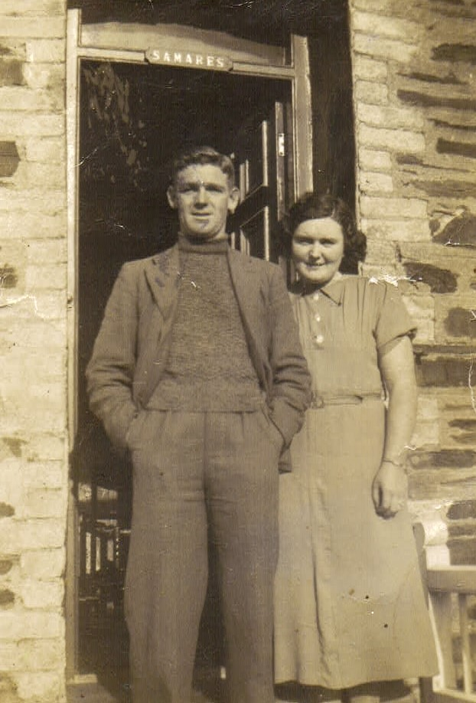
JORDAN) on FaceBook and he has very kindly shared information and photos so that has been lovely. His grandmother Anita married Fred BUNT and their daughter Eileen is Neil’s mother. Neil is my 4th cousin. He grew up with the guys in The Port Isaac Male Singing Group, The Fishermen’s Friends – I enjoy listening to the old sea shanties that they sing. Neil crewed the Port Isaac lifeboat for eight years and served in the army for many years. He started the Port Isaac Heritage FaceBook page where many people share photos and stories of the old timers. I love it!
Figure 5 Anita COUCH and her husband Fred BUNT

Getting back to Ralph – he was one of the men in the story about the 28,000 herrings and The Cissie nearly sinking. In 1939, Ralph was living on The Isle of Wight and was a seaman on a privately owned American yacht, SY Xarifa. He lived to be 79 and died in Port Isaac where he was buried at St Endellion. Anita’s husband was Fred BUNT who joined the Royal Navy the day after WWII was declared and he served throughout the war on a mine sweeper. Their daughter Eileen is Neil’s mother. Anita died in 2015 and is also buried at St Endellion.

Jack (b1922 d2009), Ralph and Susie’s 3rd child, married Millicent Mabel HARRIS and they had two children, Gordon (b1948 d2006) and Margaret who still lives in Port Isaac. When we visited in 2016, I asked if there were any of the COUCH family left in the village and heard that there was a woman named Margaret. So I looked her up in the phone book, gave her a call and we met for lunch which was lovely. She took us to the churches at St Endellion and St Kew where so many of our family gravesites are to be found. It was quite an emotional time for me. I think Jack was also a Yachtsman like his father.

The eighth child born to Frances and Hannah was Rebecca COUCH who was born in 1890 and she married John N SHORT. I have no further information about Rebecca.

Their next child was Mary COUCH who was born in 1891 but she lived for only two years, dying in 1893.

Their last child was Marina COUCH born 8 October 1894. She married George James BOTT in Plymouth in September 1931 but he died eight years later in 1939. As far as I know she had no children and she died in Totnes, Devon in December 1960.

Returning now to Francis COUCH and his wife Rebecka (my GGG grandparents), their eighth child was Samuel COUCH (b1856 d1930). He was already at sea by the time he was 15, serving on The Ada which his father was captaining. In 1878, he married Bessie HAMBLEY (b1857 d1948) and they had seven children: Kate Phillips COUCH (b1879 d1966), William Hambly COUCH (b1886 d1903), Gwendoline COUCH (b1888 d1971), Bessie Hambley COUCH (b1890), Sibyl COUCH (b1892 d1967), Doris COUCH (b1895 d1953), Mary (May) COUCH (b1897).

Samuel became a Master Mariner. In 1894, he and his brother Francis owned The Charles and John, a lug sailing rig with a foremast and a mizzen. Five men fished with lines and nets from this 5ton vessel. Samuel died on 21 June 1930 and was buried in Port Isaac.

Kate married Thomas Edwin HERBERT who was a ship’s fitter. Their son, William Hambly Couch HERBERT, was an Admiralty Foreman in 1951. The connection to the sea definitely is in evidence in this arm of the family. William died on 29 September1903 when he was only 17 and I have no information on the cause of death. Gwendoline was a servant prior to her wedding to Henry PHILLPOTS, police constable. In 1911, Bessie was the Cook in the household of George KNOWLING, a retired Naval Captain and the Managing Director of a brewery in Devon. Her sisters, Doris and Sybil, were domestics in the same household. Bessie Married Thomas K JEFFREY, a Depot Manager for a Shipping Forwarding Company, in 1919 and they had one child Walter S JEFFREY. Sybil married Bertram John TONKIN at Port Isaac in 1918 and they had two children: Bertram C TONKIN and Joyce FH TONKIN. Bertram Senior was a Shipyard Pilater. Doris married Gilbert G EDHOUSE, a Newsagent, and they had two children: Eric Ivor Couch EDHOUSE and Auriel EDHOUSE. I have no further information about May.

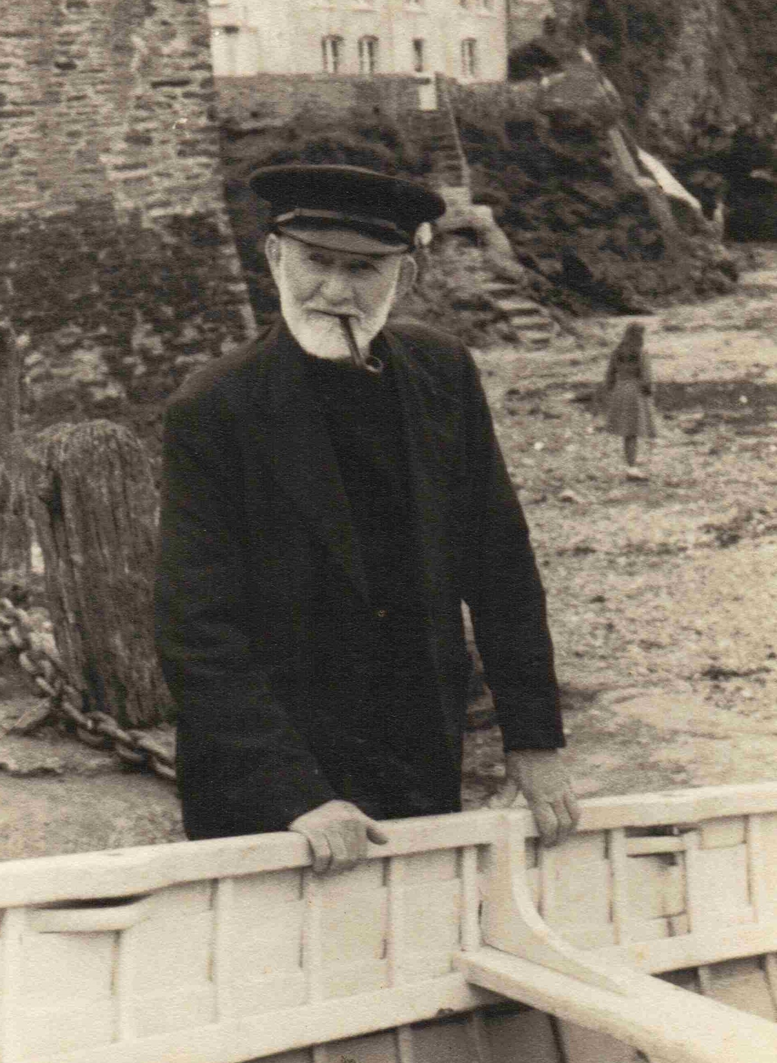
The ninth child of Frances and Rebecka was another Charles COUCH who was born on 8 June 1858. He married Elizabeth HILL at St Kew on 6 August 1881. Elizabeth’s father was a Labourer. Charles was a Mariner and a Coast Fisherman. Their first child was (Bet you guessed it!) Charles COUCH who was born on 17 October 1881 and he died in 1951. He was also a mariner and he married Lillian Mitchell (Lizzie) COLLINGS in 1910. The other children of Charles and Elizabeth were: Thomas Francis COUCH (b1884 d1965), Lizzie COUCH (b1887 d1963), Annie COUCH (b1888 d 1960), Mary Hill COUCH (b1891 -), Sarah Hill COUCH (b1893 d1969) and Rebecca COUCH (b1894 d1975). Thomas was an Inshore Fisherman and also worked on yachts. Lizzie was a Dressmaker. At the time of the 1911 census, Mary was a Housemaid and Annie, a Pantry Servant at the home of William WICKERT, a Brewery Manager. Annie died at the Royal Cornwall Infirmary on 17 September 1960 and previously she had been living at Geranium Cottage, Port Isaac. Mary married Cecil Claude POOLEY in October 1922. Cecil was a Granite Quarryman which was heavy work. They had one child, L Jean POOLEY. Mary was still alive in 1986 when her husband died and they had been married for 63 years. Sarah was a General Servant for Eleanor Elizabeth HILL living at Glentham, Port Isaac in 1911. Was Eleanor a relation? Perhaps. I found no proof however. Sarah died on 14 August 1976 at 10 Claylands St, Tudy , five km NE of Wadebridge. The last of the children of Charles and Elizabeth was Rebecca who married George LOBB in January 1915 and had one child Eileen. George worked on many yachts and fished in open boats out of Port Isaac until his death, aged 44, in 1929. Rebecca lived until 1975 when she died in Port Isaac.
Figure 6 Charlie COUCH (b1858 d1952)

The last child of Francis and Rebecka was John Hale Hill COUCH who was born in 1860. John married Hannah FISHLEY (b1861 d1937) in Plymouth in 1883. They had one daughter Hannah Fishley COUCH who was born on 11 April 1865. Unfortunately John was lost at sea on 9th March 1891 off the Vessel Zingra.

My conclusion
After all my research about the descendants of my GGGG grandparents, Charles and Honor COUCH, I have to conclude that the sea is definitely in my genes. So many of them worked on the sea. I admit that, especially in the early days of my story, the choice of career was really limited – you became a Mariner or a Fisherman or you worked on the land. They did have a choice though and working the land would have been a far safer workplace. The incomes from both are rather unreliable with both dependent on the weather. So, why go to sea? I can only conclude that it was the love of the sea that drew them to work the ships.

It is the sea that calms me when I am distressed. Walking along the beach helps me to think and solve problems. It is definitely my favourite place. I used to love being in the boats at Donnybrook but unfortunately, since we left there in 1962, I’ve had no opportunity to play in little boats. I love to sit and watch the waves roll in! It’s mesmerizing.

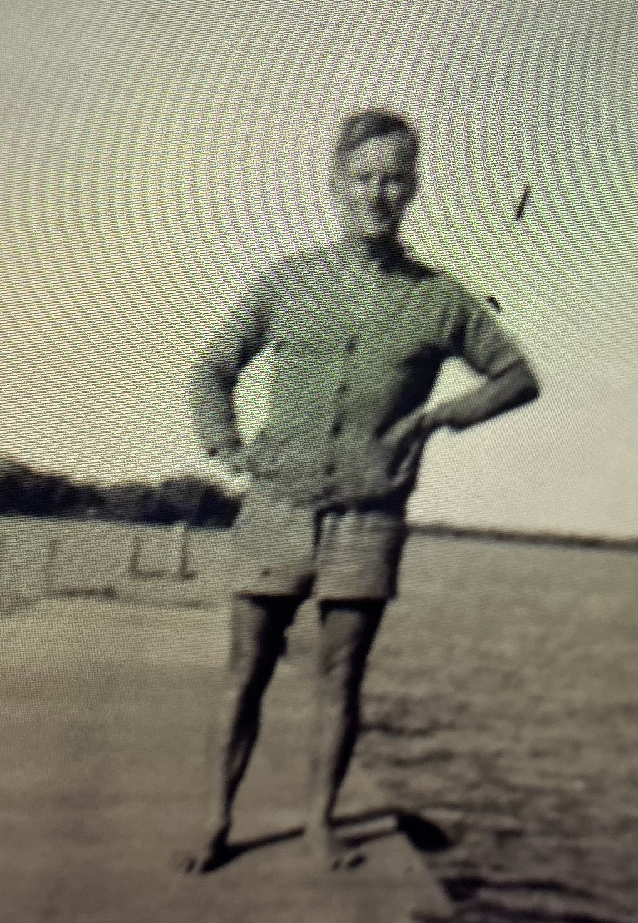
I have a final comment to make. The life of a fisherman on coastal Queensland, Australia would be a lot easier that that of a fisherman in Cornwall. Just consider the weather. If you take note of the photos of Gossie in my story and of Charles COUCH on the previous page, you’ll see the clothes that they wore. Compare that to my adoptive father, Bert RICHARDSON at Donnybrook, Queensland. This is his winter workwear. In summer, he just wore the shorts, no shirt, no shoes, no hat! Of course, that’s why he suffered from skin cancer in his later years.
Figure 7 Bert RICHARDSON , dressed for work, on his jetty at Donnybrook

I have included almost no information about the cargo carried by the ships from Port Isaac or the types of fishing which the men did. If you would like to learn more about this, please read the books by Geoff PROVIS. He covers it very well in “The Fishermen of Port Isaac” and “The Seafarers of Port Isaac”.

I hope you have found this an interesting, if confusing, tale of my ancestors and their families. I’ve certainly had fun researching their lives.

I will put all Surnames in capitals to help with identifying people
Since this story is about occupations, I will capitalise the first letters of an occupation.
Thomasine was spelt Tamzin, Thomazin, Tasmen… very confusing
Ralph is mentioned later in this tale
Free Board is the distance between the top of the boat and the sea.
Some of the ship’s names are difficult to read in the records so these are my best guesses.
The children of Francis and Rebecka will be in red to help with eliminating confusion over names.
Having been adopted out of the family at birth, I don’t know the family anecdotes. It makes me feel a little sad even though I know that I was better off in my adopted family at the time. I’m lucky that my cousins are willing to share.

