My grandfather Seymour and his brother Edward
I discovered when I was 51 that I was adopted. Now that was quite a shock, as you can imagine. I wasn’t who I thought I was. Who was I? Where did I come from? Who and where were my family? Of course, this started me on my genealogy journey to discover my origins and it’s been a wonderful journey. I’m concentrating on finding out about the life that my ancestors lived and writing their story. My focus for months has been my maternal grandfather Seymour HARRISON and his brother Edward. This is their story and to begin I want to establish how the family came to be in Australia.
Thomas Charles NORLEY was born on 17 October 1821 in Bethersden in the county of Kent in England to Thomas NORLEY and Mary BEECHING. He arrived in Melbourne Australia on 25 March 1841 on the Susan as an assisted immigrant, being sponsored by Nicholas THOMAS, as a farm labourer.
Charlotte BUTLER became his wife on 11 August 1848 at Ashfield, New South Wales. She had been born in Benenden Kent on 1 April 1832 to George BUTLER and Charlotte GLADWISH and migrated with her family on the Cornwall arriving in 1839. They were also assisted migrants.
Edward HARRISON was born on 16 October 1836 in New Malton in the county of Yorkshire to Mary and John HARRISON. He married Margaret GILLIES at Snake Valley (now Stanley) in the Bright area of Victoria on 7 February 1857 where he was a gold miner. Margaret was a Scottish lass, having been born in Edinburgh Scotland in 1835 to Daniel GILLIES and Marian McKAY. She migrated to Victoria Australia from Liverpool on the Hornet in August 1854 to work for Mr E Stamp of Geelong. I can’t find details of Edward’s migration to Australia at this time but I will keep looking and obviously he arrived before 1857.
Both Thomas NORLEY and Edward HARRISON were gold miners and their names can be found in records of the times.
At Bright Cemetery where Thomas is buried, the following information creates an insight into the man, Thomas Norley.
"Son of Thomas Nurley and Mary Beeching and husband of Charlotte Butler. Born Bethersden Kent England and died in Wandiligong Victoria Australia. Charlotte, Thomas' wife was born in Benenden Kent, some 10 to 15 km from where Thomas was born. They were married on 11th April 1848 in the Church of England Ashfield NSW where Charlotte was the daughter of George Butler and Charlotte Gladwish. It is unknown where Charlotte died and is buried. She is unable to be traced on the BDMs. From the book, "Bright Gold" written by Brian Lloyd and Kathy Nunn comes the following excerpt: "John Walker remembers Norley as a) man well past middle age in 1875 at the Cornish (mine) lifting a rock that two men of ordinary strength, John Forrester and Morgan Davies could scarcely get off the ground. When Norley worked at the Oriental Tramway he was said to be capable of lifting a derailed 2.5 ton ore truck back on its rails.

Harriet Rebecca NORLEY was the third child of Thomas NORLEY and Charlotte BUTLER. She was born at Tuena, near Bathurst west of Sydney, New South Wales on 8 September 1856. John William HARRISON was born to Edward Harrison and Margaret GILLIES on 27 November 1857 at Snake Valley (Stanley).
John William HARRISON married Harriet Rebecca NORLEY in Wandiligong Victoria on 1 March 1876. He was 18 and she was 19 and they are my great grandparents. They had twelve children in twelve years – six boys and six girls – four of whom died very young. John and Harriet lived in Porepunkah near Bright and the electoral rolls show them living there until 1917. John was a labourer and Harriet would have been very busy with her family. One of my cousins tells me that her mother said that Harriet was a bit of a tyrant but, of course, I have no proof of that.
One of those twelve HARRISON children was my grandfather, Seymour John or John Seymour, who was born in Porepunkah Bright Victoria on 13 July 1894. I am going to include his older brother, Edward Toyler, in my story as he and Seymour joined the army together and I think they had many similar interests and I think they were close (just my feeling). Edward was born in Bright on 26 June 1884 so he was almost 10 years older than Seymour.
The families were settled in the High Country or the Alpine Country in the North East area of Victoria. The area includes the locations of Bright, Beechworth, Snake Valley, Stanley, Porepunkah and Wandililong all of which appear in the various records for the family. The gold rush began in the area in 1852 with the discovery at Beechworth, then Bright and Wandiligong and all along the Ovens River. Harrietville is another small town and I wonder if it was named after Harriet but I can find no evidence either way. It’s a pleasant thought though.
It seems that they were living in Porepunkah from at least 1887 and I assume that the children attended the Porepunkah School. I have been unable to find records of the school from that time but and hoping more information will come in from my queries as I would love to know details of their schooling. The school has created a CD with many photos showing the history of the area and I was very lucky to track that down and receive a copy and for this, I am very grateful. It would have been even better if the photos included dates and names of the people in the photos.
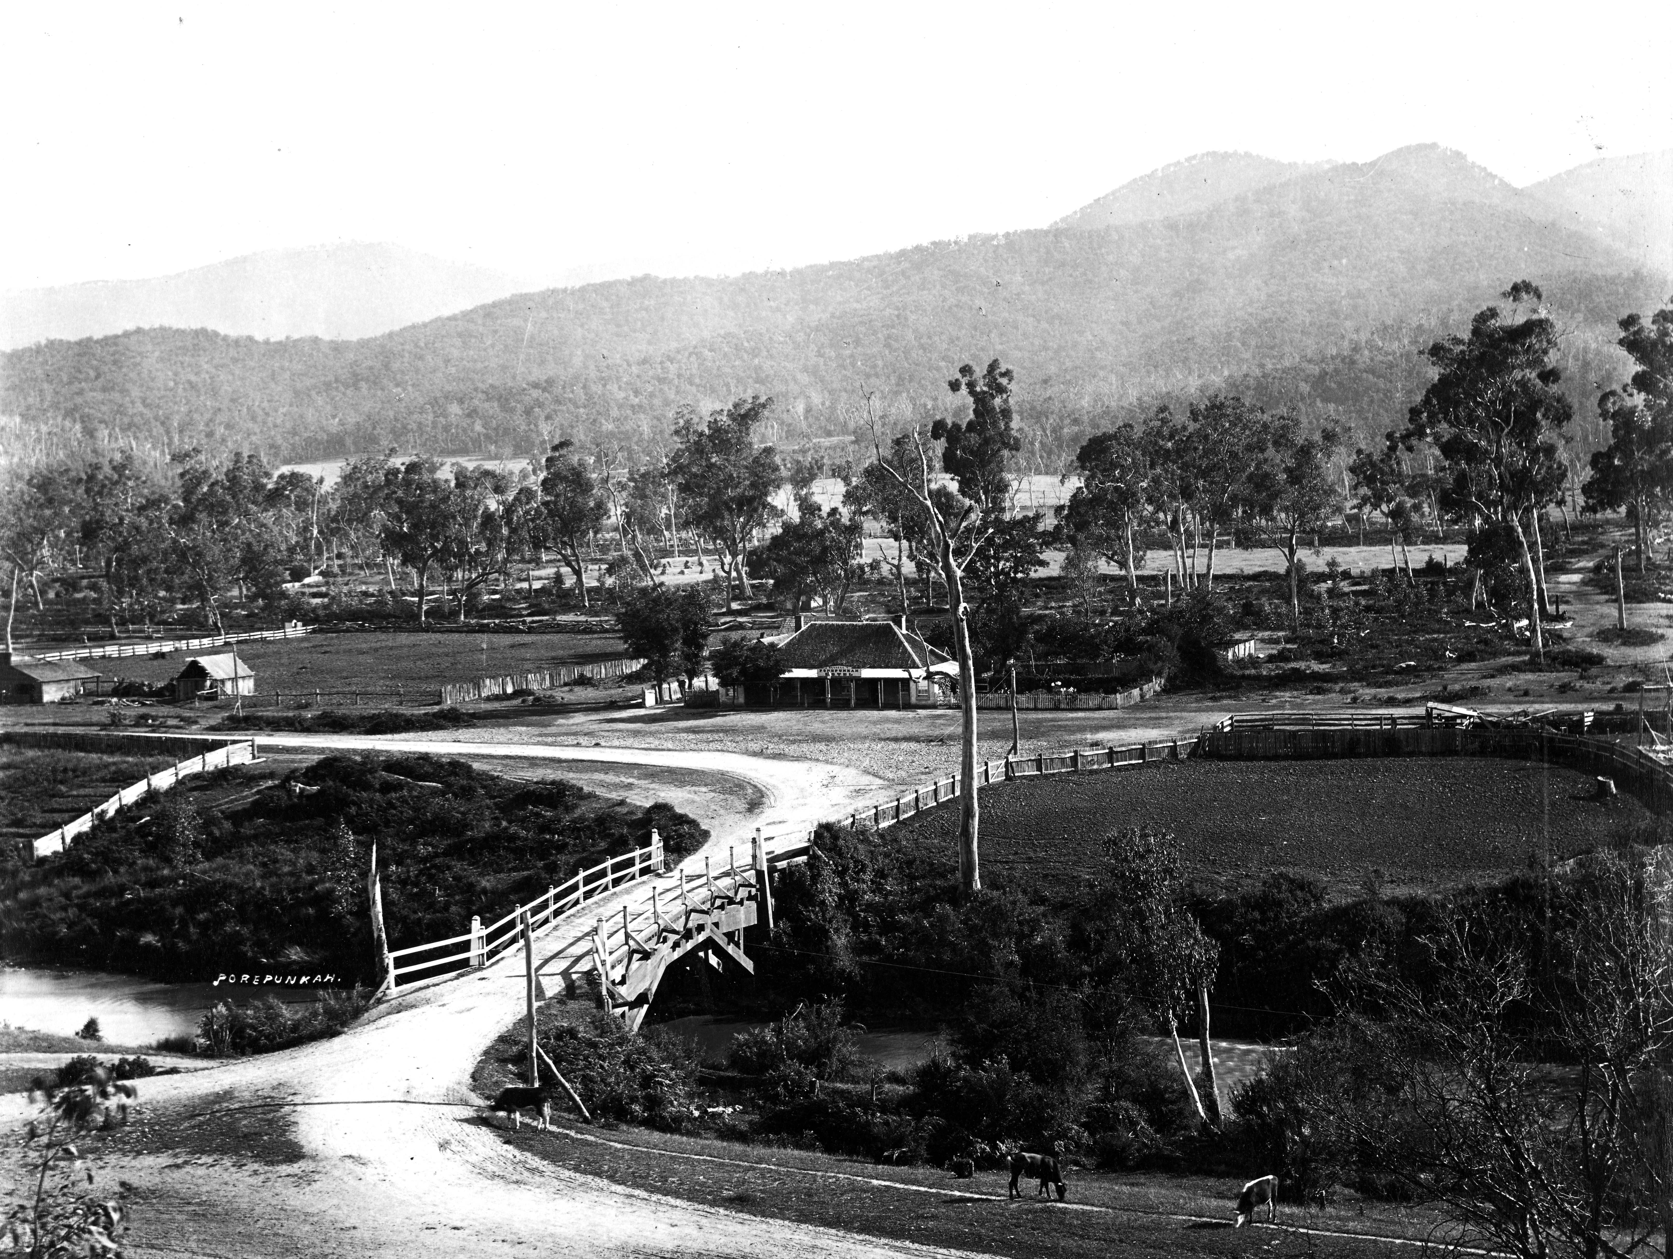
Figure 1 Early photo of Porepunkah

I know that both Edward and Seymour were sporty with both being keen cyclists, participating in many cycling events in the mountains.

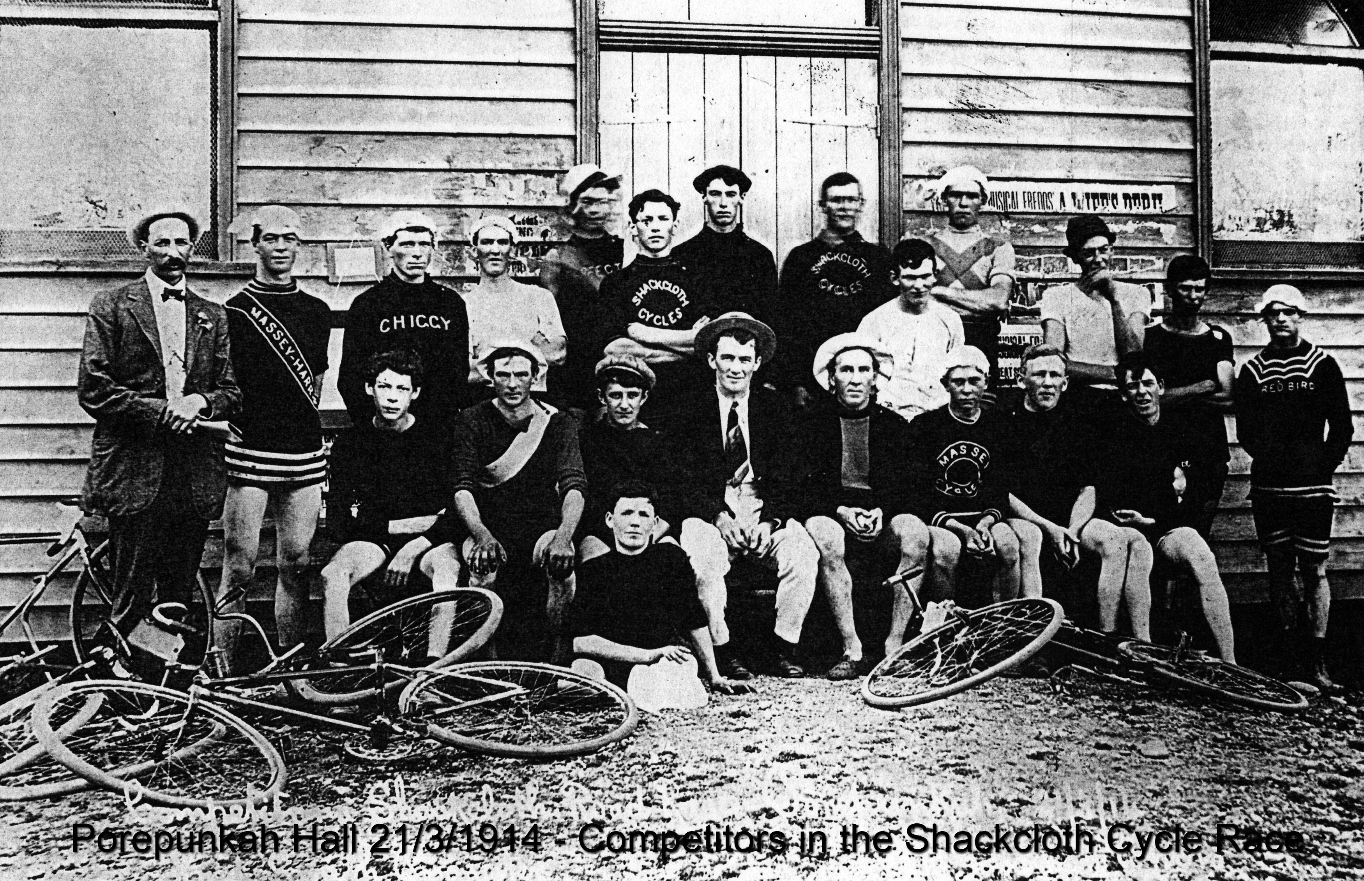
Figure 2 Seymour could be the tall fellow in the middle of the back row.
The Shackcloth road race promoted by the district champion (Mr F. E. Smith} eventuated on Saturday afternoon over the course of 14 miles from Mr G. Rayner's blacksmith shop to Walkear's, Eurobin.
Despite the fact that the cricket final at Bright drew a large number of local residents, there was a good gathering to witness the event. Where the finish took place the road was lined with spectators.
There were large entries and very few withdrew from the contest, the substantial cash prizes being tempting.
Mr W. H. Goldsworthy, who is of great assistance in sporting circles locally, acted as starter and judge, and got the field away without a hitch. The race was free from accident, although tyre and other troubles were numerous. The winner turned up in W. Pitts, of Bright, who just beat Seymour Harrison, a most fancied rider, Harrison looked all over a winner, but was overcome with cramps towards the finish, which threw him behind. O. Mills, of Wandiligong, was third, and C. Rivett fourth. V. Higgs gained fastest time, accomplishing the distance in 44mins.

"Porepunkah." Myrtleford Mail and Whorouly Witness (Vic. : 1914 - 1918) 26 March 1914: 4. Web. 8 Dec 2018 <http://nla.gov.au/nla.news-article129524737>.

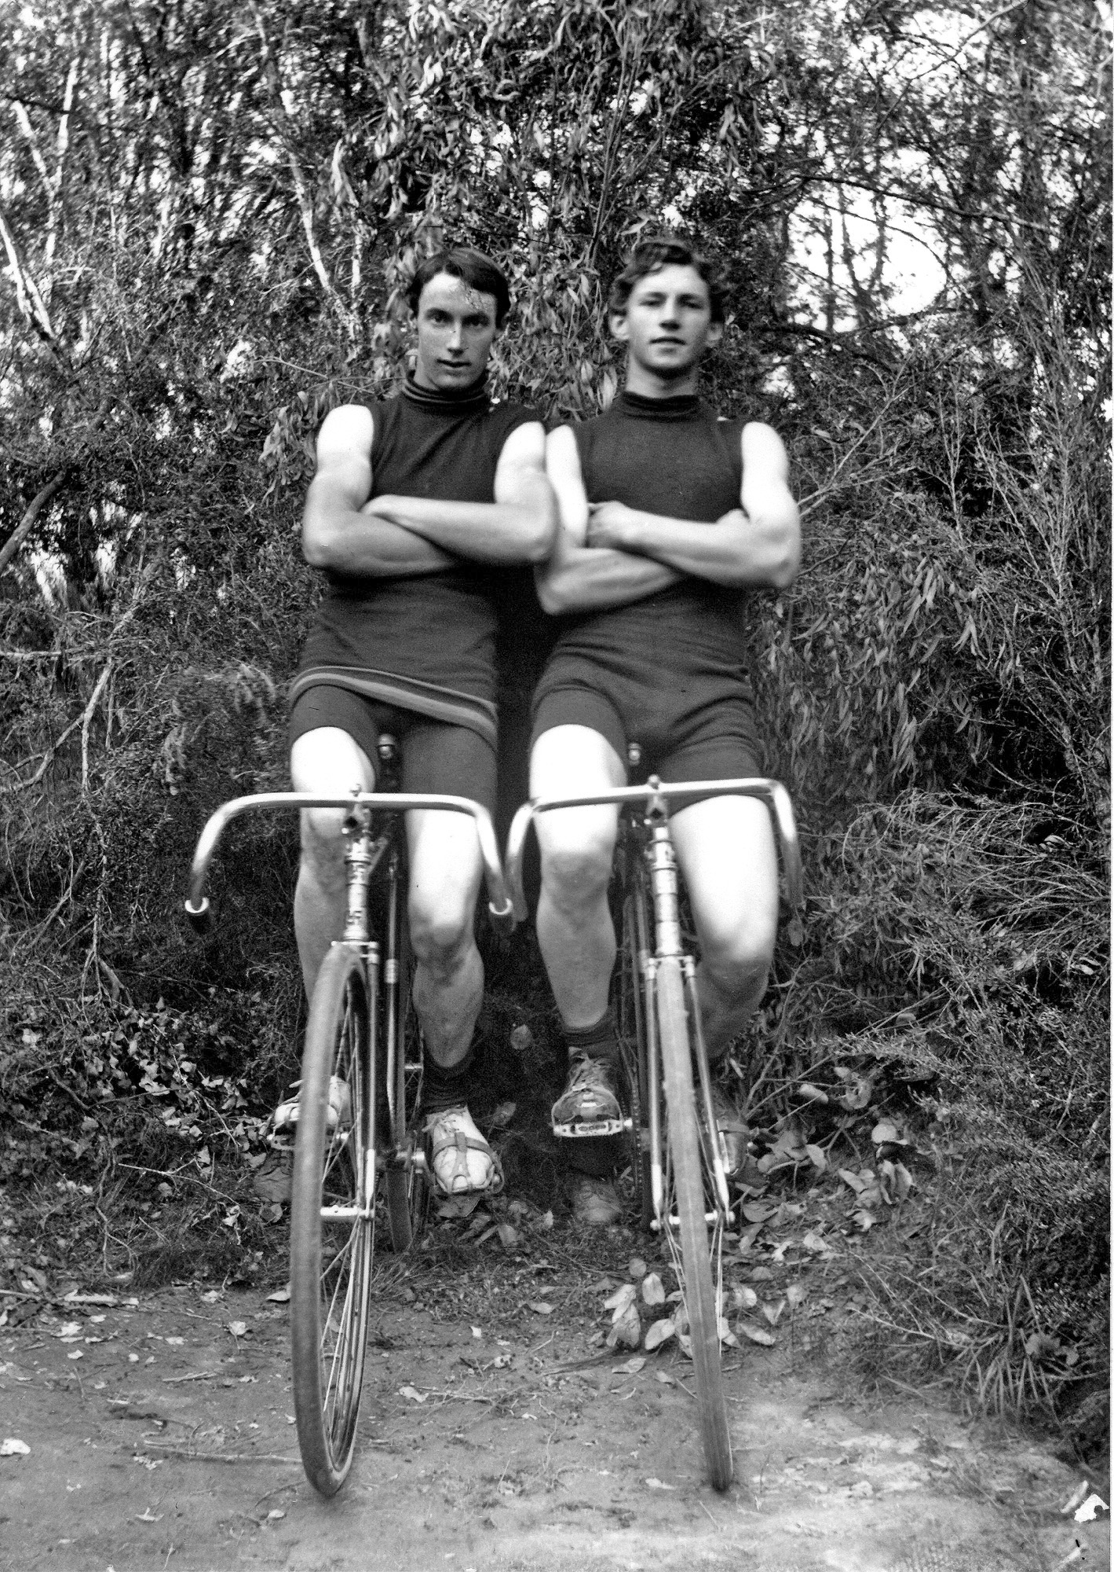
C CYCLING BRIGHT
B A bicycle match between Edward Harrison, of Porepunkah, and Andrew Wallace, of Wandiligong, for £20 a side, took place at Alpine
Park, Bright, on Saturday. Harrison won.

"CYCLING." The Age (Melbourne, Vic : 1854 - 1954) 24 April 1905: 8. Web. 24 Mar 2020 <http://nla.gov.au/nla.news-article192235450>.

Figure 3: Edward is on the right

Edward became a Police Constable on 3 August 1907 and on 4 May 1909 he married Agnes Mueller at 448 Queen St Melbourne. He had been living in Carlton and she at Ringwood, suburbs of Melbourne. In 1907 and 1909 he played a few games of Australian Rules Football for South Melbourne. He was also a woodchopper and a runner so he was an all round sportsman. On 13 July 1911, Agnes gave birth to their son, William Edward. In the 1914 electoral roll, the family are living at 261 Flemington Rd, North Melbourne.

Unfortunately I can’t find much information on Seymour during this time until both he and Edward sign up to join the army on 19 July 1915. His enlistment papers tell us that he was born in the Parish of Porepunkah near the town of Bright and that he was living in Porepunkah with his father, John, who is his next of kin. He has been a volunteer member of the Australian Light Horse Brigade for two years and works as a labourer. He had a fresh complexion, grey eyes and dark brown hair; weighed 11 stone 7lbs (73kg) and was 5ft 10.5in (1.79m) tall. His religion is Church of England.
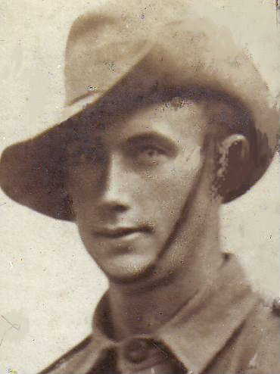
Figure 4 Seymour Harrison in uniform 1915. His regimental number was 4025

Edward’s regimental number was 4024 so they must have enlisted together. He and his family were living at 10 Elgin St Carlton when he enlisted and his wife is his next of kin. He is 5ft 9.5 ins (1.77m) tall and weighs 17st 4lb (110kg). He is of medium complexion, has brown eyes and dark brown hair. His religion is shown as Church of England.

On 8 February 1916 the brothers boarded the HMAT Warilda to set off for war. They were members of the 6th Infantry Brigade, 24th Battalion, 9th Reinforcements. They must have stayed in Egypt for a short time but then on 21 March they boarded the HT Oriana for Marseilles, France where they disembarked on 27 March. They were taken on strength (TOS) in the 24th Battalion on 6 July 1916 into was called the Nursery Sector of France near the frontlines at Armentières.

To gain day-to-day knowledge of the activities of my grandfather and his brother in the 24th Battalion, I have read Red and White Diamond, Authorised History of the Twenty-fourth Battalion AIF by Sergeant W.J. Harvey, MM. The book was first published in 1920 with a foreward by General Sir William Birdwood, Bart., G.C.M.G., K.C.B. Much of it is copied from the diary Sergeant Harvey kept through the war. I also have copies of the Official Unit War Diaries of the battalion and we were lucky enough to have a tour of the Somme with Myriam of Walkabout Digger Tours in April 2019 and she has provided me with notes of their war. My quotation marks in the next section show direct sections from Red and White Diamond.

The first couple of weeks of their service in France seemed to consist of a lot of marching, carrying heavy packs and seeking billets in haysheds etc. Furphies, or rumours had predicted that they would be staying in comfortable French houses in lovely villages so that led to some disappointment. Sometimes they marched all night carrying all their kit and blankets and there was a great deal of training to become familiar with the latest weapons.

The British offensive, known as the “big push of 1916” had begun near Albert on 1 July. On 26 July, the 24th marched to the brickworks at Albert, a town which they found in ruins after heavy bombardment. Sgt Harvey says: “The chief feature was its battered cathedral with the famed statue of the Virgin and child hanging from the ruined tower. The current superstition was that when the statue fell to the ground hostilities would cease, and on that account expectant eyes were often turned in that direction. However, it transpired that nothing short of a direct hit would bring about its downfall, British engineers having firmly secured the statue to what was left of the tower.”

Whilst waiting in Albert, they prepared for battle – gave final messages to the padre for passing on if they didn’t return, left surplus kit with the quartermaster and made sure they were battle ready. The battalion then took up forward positions at Pozières. As they moved forward, the debris of battle surrounded them and they saw many little white crosses where men had died. At dusk, they reached Sausage Valley, a valley about 400yds (365m) wide and half a mile (895m) long. It was a hive of activity with men moving forward and wounded men being taken out on stretches and in ambulances and the enemy firing on them all the time. This was to be the first big battle that Edward and Seymour would be part of. How frightening it must have been?

Their battalion was part of the sixth brigade that was to relieve the second brigade at the front. To quote from Sgt Harvey again: “About midnight guides who had been sent down from the units we were relieving reported to take our companies into position, the route being along the Contalmaison Road, then turning to the left along a smaller road past the Chalk Pit, across the Pozières-Bapaume Rd into Kay Trench, then to the allotted positions. The blackness of the night, brightened only by occasional flares over the firing line in the distance, rendered progress over the debris-strewn and shell-pitted roads slow and laborious. Gas shells falling along the route kept the men putting on and taking off their masks during the first stages of the journey, and as we got nearer the fighting area, several casualties were sustained by shell and rifle fire.”

As the relieved soldiers retired they advised that they had driven the Germans out but that they now commanded a position 350 yards (320m) away and were in trenches looking down on the Aussies and to expect counter attacks all day. At daylight, the whole area was desolate. Pozières was gone. For 36 hours the men were bombarded with fire and were often buried by shellfire and extricated by their mates. Brigade records show that casualties were 60 per battalion per hour. Horrific losses! “The ordeal of holding these ghastly trenches, which appeared to be merely waiting for death, threw many of the men into a shell-shock stupor, and stretcher bearers who struggled with the wounded had to kick the dazed men to induce them to move out of the way.” There were only 16 stretcher-bearers for the 24th and on the second day of the battle only four remained. What a ghastly job they had?

The heavy fire eased on the 28 July and the battalion had suffered such losses that they were withdrawn to Sausage Valley, officially for a rest – but how could they rest – living in shell holes and in battered trenches with continuous fire overhead and others passing on the way to and from the battle?

Another attack on Pozières ridge was planned for 9:15pm on 4 August. The 22nd and 24th battalions, about 1000 men, were to be involved and the men moved off about 5pm. “Every man was well supplied with bombs and ammunition, and carried as well as his usual fighting gear sandbags for rebuilding the enemies trenches when captured, and either a pick or a shovel to assist in the work of consolidation.” The Germans, of course, noticed all this activity and their heavy barrage disrupted the movement and it was dark before the men were in position where they were being lashed with ‘whizbangs’. “Who of those who participated in that engagement will ever forget the dash along that notorious trench? Some idea of the physical and mental strain of that night may be gained when it is considered that the men, each carrying 70lbs (31.7kg) of equipment, were pushing through a tempest of shells, and stumbling over the dead and wounded and all manner of obstacles.” About 1am, it was realised that the ground had been won and the mopping up began. In the morning mist, they could see the German soldiers retreating in groups. Many men were killed and wounded on both sides. When the battalion was relieved on 7 August, they’d been in action for 13 days and the men were exhausted. They had a few days rest at Warloy where His Majesty King George inspected the battalion. They then had a week’s rest at Berteaucourt where the locals were hospitable and the men were able to enjoy some meals of meat, eggs and chips.

On the 18 August, they headed back to battle and arrived back to Albert on 21 August where they had to prepare to go back into battle and this can’t have been easy.

Mouquet Farm (or Moo Cow Farm as the Aussies liked to call it) is an important place in the Digger’s battle of the Somme. It had been a farm in peace time but at this time, it was a German strong hold with tunnels leading away and deep underground shelters. On the afternoon of the 22 August, the 24th headed into this battle to relieve the 9th and 12th Battalions but the heavy German fire made it difficult to get into position. They changed places with the 21st battalion on the 24th and were behind the lines when German bombardment cut off all communication. On 26th when they were looking for relief, they were ordered to attack the farm immediately. The order was thought to be suicide and was fortunately withdrawn as the German position was very strong. They were withdrawn on the night of the 26 August and marched to Bonneville where General Birdwood presented ribbons to those men who had won medals at Pozières and Mouquet Farm.

Several days were spent reorganising the troops and many were promoted to replace those men who had been killed. On 5 September they marched to Doullens where they caught the train to Belgium. They detrained at Proven near Poperinghe on the 6th and camped in the Winnipeg Camp, one of several with Canadian names. The Germans had used a lot of gas in this area and there were precautionary warnings everywhere and many gas mask drills with the new box respirators. I know from family talk that Seymour was badly affected by gas and wonder if it was here that he was first confronted with gassing. The weather was pleasant and the men were undertaking light duties at the front while still having plenty of leisure time. Movies and concerts happened in the large corrugated iron concert hall. The battalion formed a football team for competitions and gambling or ‘speculation’ was undertaken on the outcome of the games. I wonder was Edward in the team – remember, he had played for Melbourne South in the Victorian Football League (VFL).

Back home in Australia, a poll was being held on conscription and the men were able to participate. The discussions around the issue were heated and many men were against compelling others to be part of such a dangerous occupation.

The work at the front here included mining under the German positions and I imagine that Edward and Seymour may have been involved here since they grew up in mining families. The men also repaired roads, trenches and gas pits.

Edward had a very eventful September. On the 9th he was promoted to Temporary Corporal and on the 30th he went to hospital for eight days with influenza but on that day, he was promoted to Sergeant and on 7 October to Temporary Company Sergeant.

On 19 October, the battalion passed back through Ypres and trained to Steenvoorde district where they were billeted until the 22nd.

And then they headed back to the Somme. The weather was cold and wet and they had several long marches before being bussed through Flexicourt, Amiens and St Sauveur to Buire. While stationed in Buire the men explored the area which proved helpful in the Spring of 1918 when they fought the Germans here during the German advance.

Sgt Harvey says that November 1916 was the worst month of their war, being a month of “indescribable agony”. They had to extend a railway near Delville Wood, about 4 miles behind the lines. “There was no camp or shelter of any kind here, and the men were marched onto a vacant piece of ground and informed that this was to be their ‘home’. A dog might have died at the thought of trying to camp in such a spot. Mud and shell holes were its conspicuous features. It was encompassed by the main roads, on which all the traffic of war ploughed through the slush; howitzer batteries on the edge of the wood kept up a continual din and drew enemy shells; the wood was reeking with the stench of the dead, and the whole aspect was one of turmoil and discomfort. The troops did not possess a blanket, and all that offered shelter from rain and cold, as well as shells, were their waterproof sheets and greatcoats.” When they returned from their labouring they tried to dig themselves a hole to sleep in but the holes immediately filled with water. Often they didn’t even get to rest in their holes but were sent out on fatigues during the night. Planes were dropping bombs and tanks wallowed in the mud. It must have been horrific!

At this time the battalion was involved around Flers. They were bringing the wounded back and taking rations and gear up to the front line. They also did some time in the front lines. “The period of operation at Flers will remain as a dreadful nightmare in the minds of the men who were there. The whole field was a vast bog, while rain, intense cold, and dense fogs continued day after day. Men strained themselves to the point of exhaustion as they floundered through the mire, sinking deep in the slush, embalmed from head to foot with mud, and, often unable to extricate themselves from the grip of the morass. Their weapons were at times clogged and useless, their clothes soaked and grimy, and their hearts threatening to sink in despair as their bodies sank in the puddle earth.”

On 10 December the battalion shifted to Pommiers Camp near Mametz, with improved living conditions but under worse enemy fire. On 23rd some moved to Adelaide Camp and some to Melbourne Camp. All were kept busy over a dismal Christmas with fatigue duty carrying supplies to the front. Correspondence from home and Red Cross parcels were enjoyed where possible. The other three units of the brigade had been away from the front for a month and in the meantime, the 24th had become known as “the roadbuilders”.

On 5 January the 24th took over the front line from the 22nd and occupied Summer, Fall and Zenith trenches. They were in the grip of winter and many men were groaning with the pain of trench feet, so severe in some cases that it meant cutting off their boots as they could be removed no other way because their feet were so swollen and discoloured. It was caused by the intense cold, blood pooling in the feet and the absorption into the feet of germs from the mud. Many men were taken out on stretchers, others hobbled out, some piggy-backed their mates. They must have made a sad procession! Fatigue duty continued until 14 January when they were moved back to Ribemont where they trained for the rest of the month.

February was a mix of time at the front, training and patrols. The weather was beginning to thaw. Sgt Harvey says the men really appreciated their ration of rum during the winter and the soup kitchen which was set up half way between the front lines and the camp so that the men would get a hot cuppa or some pea soup to cheer them on their way back to camp. The battalion band was also a morale boost as it would be at the half way mark to help them march back to camp. It would march back with a group of men and then return to the half way point to escort another group back, sometimes repeating this four or five times. In order to move safely over the snow, the men painted their helmets white and wore white overalls which were often women’s nighties bought in Amiens. It must have been a strange sight.

The following article appeared in the Yackandandah Times in Victoria on Thursday 1 March 1917 :
Sergeant “Toiler” Harrison previously of Porepunkah is having a splendid time in France. In a letter to a friend in Bright, Toiler says:-“Having a few moments to spare I thought I would write you a few lines to let you know I am still alive and in good trim – just about good enough to win another Alpine Wheel Race, having got down to may racing weight through hard work. We are having a fairly good time her – plenty of fight. I have been through all the stoush here since June and I can tell you there was something doing. You could never imagine what it was like. I suppose you have read of it in the papers. I would like to be up on the old Bright track again. They were the best days of my life and I never realised it until now. The French are fine people when you get to know them but their lingo is, well I do not know what to call it. You can understand people in Egypt but when it comes to French I call a halt. We manage to get along somehow. I have been from one end of France to the other and all over the middle of it. Well about Fritz: he is not much of a guy when you get up against him but he is a great long distance fighter and would also make a good wombat, the way he digs himself in. I tell you he takes some rooting out but we will manage it alright in time. He is a fine artillery shot and his coal box is something to gamble upon.

On 2 March the battalion moved forward and met up with the Germans opposite Avenue les Bapaume near Grevillers and they advanced here after a number of raiding parties took the battle to the enemy. This was where Edward was severely wounded in action with gun shot wounds to his head and his face on 4 March. He was taken to 1/1/ South Mid Casualty Clearing Station by the number 5 Australian Field Ambulance and then transferred to the Ambulance Train on 5 March. He was admitted to the Number 7 Canadian General Hospital in Etaples on 5 March where it was noted he was dangerously ill. He died there, of his wounds at 11:30pm on 13 March 1917. He was buried in the Etaples Military Cemetery. Sgt Harvey states that a number of men were killed in this exercise, among them Sgt E Harrison. He added that they were all gallant soldiers. Edward was demoted from Temporary Company Sergeant to sergeant after he was wounded. The battalion war diary says that one man was killed and one wounded on the 4 March so, I guess, the wounded one was our Edward.

I’d love to know if Seymour was there with him when he was wounded. Were they in the same company within the battalion or had they been split up? Either way, I’m sure Seymour would have felt it deeply when his brother died. Here is one of the news articles that were published in Australia about Edward at the time.

("TOILER HARRISON KILLED." Record (Emerald Hill, Vic. : 1881 - 1954) 14 April 1917: 2. Web. 30 Mar 2020 <http://nla.gov.au/nla.news-article75013644>.
"TTOILER" HARRISON KILLED.
FFFORMER CONSTABLE AND LOCAL FOOTBALLER.
News has come to hand of the death in action on March 13 of Constable E. W. Harrison, formerly of South Melbourne, a man of splendid physique, of manner most genial, and of that type which puts duty before everything. His death is deeply regretted locally. Besides being known as a constable, "Toiler" Harrison was an athlete. In the north-eastern district he made a great name for himself as a footballer, and in 1906 he stripped for South Melbourne. He stood down for the two following seasons, and played again (one match only) in 1909, the season when South won the premiership. We extract the following notice from the "Myrtleford Mail":
"Throughout the district there was probably no better known native of our little town than Edward T. Harrison, better' remembered as 'The Toiler,' of whom the news was received on Friday last that he had paid the great price and had laid his life down for King and country in far away France. The late Private Harrison was at the hour of his enlistment a member of the police force, in which he had served for some years, being stationed in various parts of Melbourne.
As an athlete, he was one of the best, if not the best, all round man in the North-Eastern district. As a cyclist there was no one in the district who could compare with him; he was one of the leading footballers, an axeman who won several contests, a runner who many times was first past the tape; whilst at throwing the hammer, weight-putting, and tossing the caber he had many wins to his credit. In fact, on two or three occasions at local and district sports he took almost every event on the programme. He was also a fair cricketer, as well as a useful member of the local rifle club. "The Toiler" was physically, what might be termed a model man, being big in every way, and when seen in khaki was an ideal type of soldier.
As a boy he attended the local school, and upon the news becoming known the school flag, as well as the Progress Association's flag, was hoisted at the half-mast as a token of respect to one whose death brought home to every local resident a realisation of the dreadful toll this devastating war is levying upon the best and bravest of our boys. The dead hero has, besides his parents, brothers and sisters, left behind him a young widow and child to mourn his untimely end.

The Germans were pushed back to Bapaume and the forward movement is said to have given the men fresh energy but they were busy moving all the gear forward into new areas. The 24th had been in action for four days and were withdrawn and undertook some route marches and training but had time for concerts and some relaxation. The war diary notes that the 24th was the day for baths and the men looked more fit! It was still very cold and snowy. On the 30th the band accompanied them on a route march. I think it would have been so much easier to keep on moving if you could hear the stirring tunes of a brass band.

The first battle of Bullecourt began on 11 April and apparently Seymour was close by but not actually in this one. The battalion was relieved and sent to Favreuil where they were resting and cleaning up. (It was on this day during the first battle of Bullecourt that David’s cousin, Robert Wachman, in the Fourth Division 48th Battalion was killed in action.) The Fourth Division had captured a portion of the Hindenburg Line but they had to retreat as they couldn’t hold it. Read my blog about Robert here:https://wordpress.com/block-editor/post/dapperdaveanddinkydi.com/1034

A copy of the layout of the battlefield that they would encounter when they advanced to the front to try to retake the lines at Bullecourt was laid out at Favreuil. The 24th battalion practised first in daylight and then at night on this mock-up of the actual site. Platoon commanders received copies of all maps and aerial photos etc and all information was passed onto the men so that even with high losses of officers and N.C.O. the men would know what had to be done. The men had to exercise hard but everything was done to keep them happy; a canteen was opened and regimental funds were used to buy extra food for the men.

The second battle of Bullecourt started on 3 May 1917 and Seymour is in this one. “ Picture two perfectly made enemy trenches on the slope of a long rise, protected with four or five belts of wire, which in places were 30 yards (27.4m) in depth and breast high, and sighted to such perfection as to enable the German machine gunners to fire along the fringe of the wire. To reach the first trench meant an advance of nearly 1000 yards (914m) over ground which afforded no shelter for advancing troops, beyond one or two sunken roads leading from our positions to the Hun lines.” Myriam took us to the location of this battle and we parked on a sunken road from which we could see the field in which Robert’s body lies. Now it is such a beautiful green field. It’s hard to imagine what it must have looked like then and how it must have smelt with all the bodies left behind in the rapid withdrawal of the first battle.

“Our line offered a striking contrast to that of the enemy. The Germans were posted in deep, well-made trenches and protected dugouts behind a mass of wire. Our line was nothing but the shattered embankment of an old railway and was approached over open ground.”

“Before leaving camp every man was issued with rations for 48 hours. Two sandbags were wrapped around the legs over the puttees and two thrust through each of the shoulder straps of the tunic. ….. the troops collected extra ammunition and six Mills bombs each, while some carried picks, shovels, boxes of bombs, flares for signals, and expanding wire netting for bridging uncut wire entanglements. The average load per man must have been not less than 100lbs (45.4kg).”

The 24th battalion had a frontage of 340yds (310m) with the objective to reach the area 1600yds (1463m) from the railway embankment. Sgt Harvey gives an excellent description of how the four companies of the battalion moved forward in turn and captured their objective, the second German trench (OG2). It was a desperate battle. The war diary is faded and difficult to read but I can see that they took 50 German prisoners and Sgt Harvey says that these were used as stretcher bearers for the many casualties. At 3:30 in the morning the battalion had been a fighting force of 586 men. By 3pm, there were 8 officers and 113 men holding a frontage of 600yds (549m). They then were ordered to take another 200yds (183m) of frontage, which they did, but the men were exhausted and were very happy when all were relieved by 3:20am on the 4th May.

Sgt Harvey states that this battle was one of the hardest that the Battalion was involved in. On the 5th May, the Brigade was reorganised. Each of the four battalions had only enough men to make one company and they were held in reserve. On the next day they were ordered to Favreuil and this was the beginning of a prolonged rest from battle. They spent happy times in Warloy and Wardreques where they trained hard during the day but had free time in the evenings. They intermingled with the local civilians and met up with family members or friends from home who were nearby in other battalions. Their band was quite accomplished and put on concerts for troops and civilians and sporting challenges were issued and matches held. The men enjoyed bathing in the canal that runs through Arques. The biggest threat at this time was the bombers at night and these were constant.

In July, Seymour went to a Tattoo and returned to camp two days late so he was docked ten days pay. Where did he go? Did he meet up with old friends from Bright in Victoria or did he drown his grief over Edward’s death in alcohol? Of course, all of the men would have lost mates. It must have been dreadful. I can understand them needing to get away from everything for a couple of days.

Several drafts of reinforcements had arrived and soldiers had returned from hospital so that by the time they returned to battle, the battalion was at full strength and the men were efficient soldiers. By September they were preparing for battle once more, having marched to Steenvorde and then to Devonshire Camp. Models of the fields of battle had been marked out and the men knew the layout of the area from training on the models. The roads were clogged with army vehicles and camps were spread out in all directions. Back five to ten miles (8 to 16km) behind the lines, planes from both sides flew over the area, dropped bombs, undertook surveillance and fought in the skies. “The crashing bombs demolished buildings, scattered dumps, killed men and horses, and kept everybody, including the few civilians who remained there, restless and fearful.”

“In the trenches war’s routine – sniping, patrolling, bombing, out-post and strong-post activities, digging, observing, repairing the destruction of bombardments, and the evacuation of wounded – went on unceasingly.”

All were expecting the grand offensive against the Germans.

The battle was to begin at dawn on 20 September with the final objective being Passchendale Ridge with many minor objectives on the way. The 24th Battalion was not in the front line on this day but their duty was to keep the ammunition and supplies up to troops in the front line. The evening of the 19th was wet and roads quickly became waterholes and the sky was very black. One hundred and twelve of the men were tasked to be stretcher bearers, carrying the wounded to Menin Road and then the fields were littered with so many dead, especially German soldiers, that the battalion supplied a burying party. This continued until the evening of the 23rd by which time 14 men were killed and 76 wounded. The battalion withdrew to Devonshire Camp.

The attack resumed on the 26th September and the men were ready to return if needed. The 24th was to be part of the attack on Broodseinde Ridge and this battle began on 3 October.

However Seymour was not to be part of this. His war took a different turn. On 27 September he was admitted to the 5th Australian Field Ambulance with scabies. On 2 October he was transferred to the 26th General Hospital at Étaples with dermatitis and on the 5 October he was transferred to the 25th General Hospital. On 22 October he was transferred to England and admitted to the 2nd Military Hospital, Old Park, Canterbury with dermatitis on his right leg and his arms. He was discharged from hospital on 23 November to furlough until 7 December when he reported to Depot Sutton Veny. On 8 December he marched into No 1 Command Depot at Sutton Veny and was classified B1A4 which apparently means he was able to route march ten miles (16km) and see to shoot and hear well. (That’s the best explanation I can find online.) On 18 December he marched into the Overseas Training Brigade and he returned to France on 5 January 1918, rejoining the 24th Battalion on 9 January.

Whilst he was away, the Battalion had been involved in the major attack on Broodeseinde Ridge near Ypres in Belgium on 4 October 1917 and the allies were successful in gaining this vantage point although there were heavy losses again. Many German prisoners were captured. On the 9 October and 10 October in an advance on Daisy Wood, the battalion’s losses were 24 officers and 392 other ranks. By the 10 October, the four battalions of the Brigade managed to form one composite battalion out of the men remaining. After this terrible time, the men were rested, undertook training and competed in sports events.

When Seymour rejoined the battalion they were in Lottinghem where they were enjoying five weeks of leisure. Men were given a day’s leave at the seaside at Boulogne; they played football and some even had two weeks leave in England.

The battalion doesn’t return to the front until 6 March 1918 by which time Seymour has left the 24th Battalion for the last time. On 5 February he was admitted to the 6th Australian Field Ambulance with synovitis of the right knee and this would have been very swollen and painful. He was then transferred to the New Zealand Stationary Hospital at Wisques in France. On 21st February he was transferred to the 53rd General Hospital at Boulogne and on 29th March he was transferred to England and admitted to the Norfolk War Hospital, Thorpe.

NORFOLK WAR HOSPITAL
The ever increasing need for beds for injured soldiers led to the Norfolk County Asylum being taken over by the War Office. It was hurriedly adapted to house additional nurses, and all the facilities needed for their new military patients. Opened in April 1915, the Main Hospital and its Annexe started with 500 beds each but by 1918 the Norfolk War Hospital provided 2,428 beds. By 1919, an incredible 44,651 patients had passed through and 8,657 operations carried out as convoys of wounded men arrived.

From here he was sent to the No 1 Australian Auxiliary Hospital at Harefield House. This House was planned as a place for soldiers to recuperate when they were discharged from hospital before returning to the front. Initially meant to house 50 soldiers in winter and 150 in spring and summer, it eventually cared for 1000 men at a time. Even so, its history indicates that men could enjoy the billiards room, the writing room, the grounds and could go off for picnics or catch the train into London.

On 29 April 1918 he was discharged from hospital and sent to the No 3 Command Depot at Hurdcott. Men were sent to the command depots to be trained and to achieve peak fitness after hospitalisation before being returned to the war. On 8 June, he marched into the Overseas Training Brigade and on 12 September, he returned to France, marching into the M.G.C.B.D at Camiera. [I can’t find meaning of this acronym but I assume is it the Machine Gun Company Battalion Depot?] I have read The Last 100 days by Will Davies to put together this part of Seymour’s story along with the War Diaries of the 3rd MG Battalion.

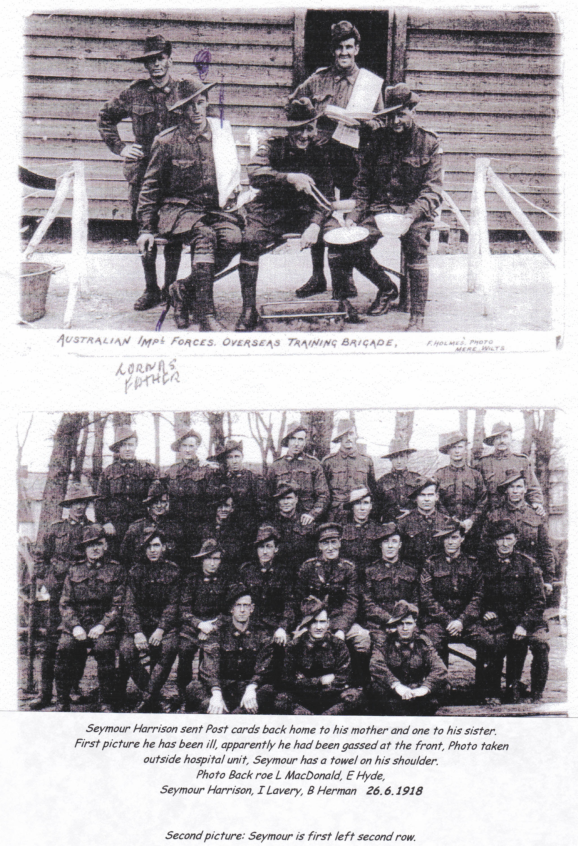
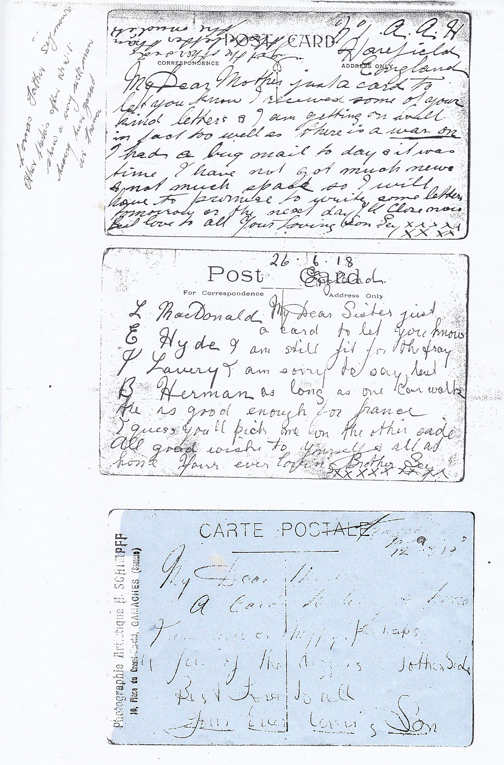
Figure 5 Seymour sent these postcards to his mother and sister on 26 Aug 1917
On 16 September he was taken on strength into the 3rd Machine Gun Battalion back in the Somme. I wonder how he felt returning to the battlefield after some six months in England, healing and recuperating. I imagine he would much rather have been on a ship to Melbourne. His new battalion had just been involved in heavy action on the Mont Saint Quentin area and had suffered many casualties and taken many prisoners in the advance towards the Hindenburg Line. Seymour joined them where they were billeted in Buire and Hamelet, near Villers-Brettoneux. The battalion war diary shows them moving off at 6pm to take up positions at the front where they remained until the morning of the 20th when they returned to Buire. During the next week much training was undertaken and organised games and sports were played and equipment was prepared for battle.

At the end of September there was to be a big push to breach the Hindenburg line. It was a formidable line protected by a determined, well-equipped force that needed to be overcome if the war was to end before winter came again. The attack was planned to begin at 5:50am on 29 September. The Allies under Gen Rawlinson and Lt Gen John Monash had 1600 guns including 593 heavy guns and howitzers and 1044 field guns. On the 4th Army Front, these would fire one million shells. For the first time, 30,000 mustard gas shells were used by the Allies although the enemy had been using gas for over a year.

Each of the four companies of the battalion was allocated to a brigade and since I have not been able to identify which company Seymour was in, I do not know where he fought in this battle. American troops were also in this battle but were not accustomed to such dreadful fighting and suffered terrible casualties.

By 1 October, the allies had not reached the objectives that had been set and the German army was resisting and even counterattacking. The fighting was severe and the Australians received heavy artillery fire and had to wear their gas masks for hours at a time as they were bombarded with gas shells. Family members tell me that Seymour was badly gassed and suffered its effects for the rest of his life. I can’t imagine how awful that was – my respiratory system doesn’t even cope with a squirt of fly spray.

However, by midnight on 4 October, the Australians held a 6,000 yard (5.5km) front from north of Joncourt to Prospect Hill and the British held another 5,000 yards (4.57km). The men were exhausted and had suffered heavy casualties. But still they fought on. And they secured the Northern Flank of the Line. They won.

This was the last major battle that the AIF fought in WWI. During the remainder of October, the battalion was behind the lines at Hornoy, west of Amiens, resting and systematic training was undertaken under the guidelines laid down by Battalion Headquarters. Church parades were held and sports were played – Rugby League for the Queenslanders and New South Welshman and Aussie Rules for the Victorians and others. Baths were built and bathing parades were held and the men were issued with clean underwear. It’s hard to imagine how grotty, smelly and unpleasant they must have felt so many times during the war – covered with mud, blood and goodness knows what else. How good it must have felt to be clean and playing sport?

This continued on into November and on the 11th the War Diary of the 3rd MG Battalion says: “News of signature of Armistice released and the town beflagged. Great rejoicing by the inhabitants. The Battalion Band played a special program in the Market Square.”

Will Davies in The Last 100 days states that the Aussies were sceptical and did not celebrate as enthusiastically as the other nations and the local French inhabitants who really made a fuss of the Aussies. To quote Will: The evening of 11 November, the men began to take in this momentous news: “Sitting around the braziers in the evenings, all manner of ideas were exchanged. What did an Armistice mean? Would we go to Berlin? When would we be likely to reach home? What did the future hold for us? While many other questions came up for discussion, deep down in the hearts of all was an unexpressed feeling of thankfulness that the strife was over.” The noise had quietened. The guns had stopped. They could put aside their gas masks and lay down their guns. They could now think positively of going home to their loved ones.

Following the Armistice, life was a cycle of route marches, sports, inspections, church parades cleaning equipment and training. On the 30th November, the Battalion gathered in the Market Square for a lecture on demobilisation, education and repatriation. The weather was wet and getting cold and the mud was making the transport lines difficult to cross but parcels arrived from home and the battalion used its funds to buy fresh vegetables.

In December, life carried on in the same vein – training, cleaning sports etc. A trotting race day was held and a Tote was run. “The Cooees”, were formed from the Division Concert Party and they gave nightly concerts in the village. On 9 December, the Battalion moved to Huppy, north west of Amiens where new billets had to be cleaned and improved. Christmas Day was celebrated with a visit by the Commanding Officer and arrangements had been made to ensure the men were in good spirits, according to the War Diary. Training was being undertaken in trades such as wool classing that would be helpful when the men returned to Australia and were seeking employment.

The men had a day off from training on New Years Day and were occupied playing sports and then the training, route marches cleaning etc continued. On 11 January they were moved to new billets in Gamaches, a four hour march closer to the coast of France. Life continued in the same routine but in new surrounds.

There were not sufficient ships to bring all the men home at once. The Spanish flu was virulent and spreading through the world and measures were taken to protect the men. The men could only come home in groups and the first two groups of the 3rd MG Battalion left in February. For the others including Seymour, life went on as before. The stores were being packed up, ammunition stored and training continued. As well as classes in the trades, men could study office skills such as bookkeeping in the hope that this would help with employment in Australia and playing football kept them fit. In March more men were marched out on their way to England and then home.

On 14 April, Seymour marched out to Le Halve to board the ship to Southampton. He was part of the second last group to leave. For more than six months, they had been training, playing football, doing route marches and generally filling in time. How did the men deal with that mentally when surely they just wanted to get home or at least to England? They must have all been suffering from Post Traumatic Stress Disorder (PSTD) from their horrific experiences and then to be unable to get home to their loved ones would have added to their anguish.

Seymour’s war record shows that he disembarked at Southampton on 15 April but it wasn’t until 27 May that he embarked on the Rio Pardo for Australia. Apparently on 31 May he was severely reprimanded by Lt Col McColl for disobeying a command from his superior officer. I guess all the men would have built up a fair level of frustration by this time so I’m not too surprised at this. I think they would also be concerned about where life would take them when they arrived back in Australia. He disembarked in Melbourne on 18 July, having been away for 3 years and 4 months and was discharged medically unfit with a disability of chronic bronchitis on 12 September. He was a Lance Corporal and received the Victory Medal.

I have to wonder how this young man would have changed. He left Australia a very fit, healthy young man who grew up in the rugged Alpine region of Victoria. He returned medically unfit with chronic bronchitis and always had trouble breathing. Mentally and emotionally he must have been even more damaged (as I think all soldiers returning from the battle field must be). How could these men wipe their memories of the terrible things they had seen and the terrible things they had experienced and done? How did any of them return to normal everyday life? Where would they find work? It seems that he returned to Porepunkah where he worked as a wood carter.

We think that Seymour met Mary Elizabeth BURGESS at a dance in Brighton, a suburb of Melbourne before he went to war as, just five months after he returned to Australia, they married by the Reverend Alfred Madsen in the Methodist Church, New Street in Brighton on 19 November 1919. Mary was the daughter of Joseph BURGESS and Rebekah HAWKER and she had been born at Laverton Werribee Victoria on 2 April 1894. Joseph who was born in Tarporley, Cheshire, England on 2 July 1865 had arrived in Melbourne on the Gilereux on 7 February 1887. He was a weaver but became a very successful dairy farmer in Melbourne. Rebekah was born in Wyndham Victoria on 25 November 1871 after her parents, Isaac Hawker and Elizabeth Couch migrated from Port Isaac, Cornwall to Melbourne on the Accringtom in 1862. Rebekah and Joseph married at Werribee in 1893.

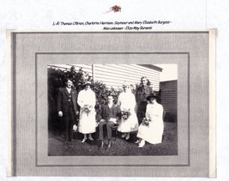
Figure 6 Wedding of Seymour and Mary. L to R Thomas O'Brien, Charlotte (Lotte) Harrison, Seymour, Mary, unknown man and Eliza May Burgess
Seymour and Mary had four children: Mona was born in 17 October 1920, John Joseph was born on 15 January 1922, Lorna May was born on 31 October 1924 and Jean (my mother) on 17 January 1926, meaning they had four children under 6. All of the children were born in Brighton. Mary had been a teacher employed by the Victorian Department of Education prior to 1916 but lived with her parents between 1916 and her marriage and did not teach during that time.
In 1931 she filed for divorce from Seymour who was definitely having trouble settling back into everyday life and taking on his responsibilities. It seems that between their marriage and 1931 Seymour had been in and out of employment in a range of jobs including: dairy worker, motorman and conductor on the Melbourne trams, wood carter, saw miller, police constable, tannery presser, letter sorter and skin buyer. One of my cousins told me that Joseph bought Seymour a sawmill at one time but that he couldn’t make a success of it. However I can find no records of this.
The family moved around a lot living in eight different locations in that time. Just imagine the turmoil for the children changing schools and making new friends every time! In 1924 Seymour was discharged from the police force for drunkenness and in 1925 he spent two months in the Caulfield Military Hospital when his health suffered because of the gassing during the war. Reading the divorce papers filed by Mary made me so sad. The relationship disintegrated as Seymour’s alcoholism increased and Mary returned several times with her children to live with her parents. In 1927 Mary returned to teaching and this must have been very difficult with four young children but I suppose that their grandmother, Rebekah, cared for them. The divorce was made absolute in 1932.
In the electoral rolls, I’ve found Seymour who seems to change his name to John Seymour or just John Harrison living with his mother Harriet and his sister Pansy Grace at 2 Eskine St, North Melbourne between 1931 and 1942. He is listed as a labourer and Pansy as a machinist while Harriet looks after the family. This was the time of the depression so I imagine finding work is you were unskilled was very difficult.
I suppose that is why Seymour enlisted in the army again at the Melbourne Town Hall on 16 September 1941. He listed his usual occupation as sawyer and turner but said he was currently employed as a rigger. His attestation form gives his army number as V19437. Sadly, even during this time, his alcoholism continued to be a problem.
In 1943 I think Seymour found some happiness again. On 14 August at St Michael’s Church of England in Carlton, he and Dorothy Joyce Lesar were married. She was 28 and he gave his age as 41 but he was actually 49. She was a factory hand – could Pansy have introduced them – she was a machinist? They look so happy in the photo.
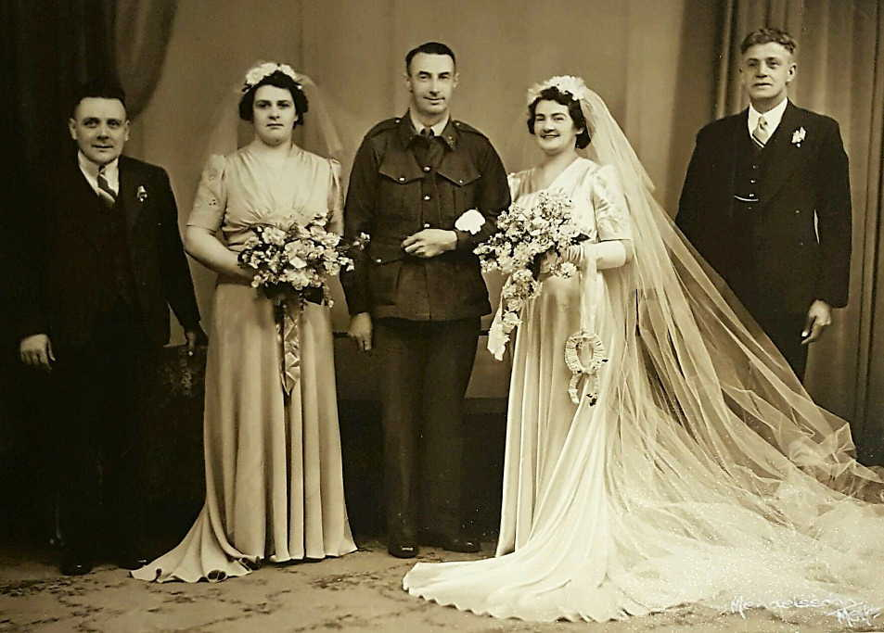

Dorothy and Seymour moved to Narrabundah Canberra in the Australian Capital Territory. They had a son who would be about my age so I will not give any further details about him as he is probably still living and he has his right to privacy.

Seymour died in the Canberra Memorial hospital on 26 June 1962 and was buried in the Woden Cemetery plot H-EX-E-003 Memorial ID 180601803.

Of course, having been adopted out of the family and not discovering this until 2001, I did not meet Seymour and it has been important to me to find out about his life. I feel for him. He went off to war with his brother as a fit and healthy young man. He came back alone as so many of our young men did – battle-scarred and weary – and unable to resume a normal life and take on life’s responsibilities. It hadn’t been named then but I have no doubt that he suffered from Post Traumatic Stress Disorder and there was no support available for the emotional and mental strain of war at that time.

I think learning this story also helps me to understand my mother, Jean. When she was young her family was in chaos. Sometimes her father was there and sometimes he wasn’t. He was an alcoholic and she became one too! She was in relationships with many men. Her life was such a mess.

I wonder how Seymour’s life would have been if he hadn’t had to go to war?

